Machine Learning in Membranes: Where Are We Now and Where Are We Going?
Paula(1), Lawrence (1), Kean, Pulak, Xiaolu, Hokyong Shon, Am Jang, Ying Li Hanyu*, Alicia * (9 authors)

Introduction
The engineering of modern polymeric membranes is rooted in an old intellectual rebellion. When Swedish chemist J. J. Berzelius first coined the term "polymer", the scientific community fiercely resisted the idea that molecules could link into the giant macromolecular chains we now use to filter gases and liquids. It took a decades-long professional battle by Hermann Staudinger, who was later recognized with the 1953 Nobel Prize, to prove these structures were even possible[1].
Today, those once-contested macromolecular networks form the bedrock of global separation technology. Polymeric membranes have become crucial across modern industries due to their durability, low cost, and straightforward synthesis [2,3]. This combination of practical operability and economic viability has driven massive development in membrane technology. A major strength of these polymer-based systems lies in the high degree of freedom offered during fabrication, where processing parameters can be precisely adjusted to tune pore structure, thickness, and transport properties for application-specific performance requirements [2,3].
Driven by these structural advantages, polymeric membranes have been adopted across an expanding range of fields, including water and air purification, gas separation (i.e. CO₂ and N₂), and various biological and biomedical applications [4,5]. While ongoing research continuously seeks to improve material efficiency, selectivity, and durability, conventional empirical development is hitting a bottleneck dictated by the sheer complexity of the multi-variable design space.
Over the last decade, machine learning (ML) and artificial intelligence (AI) have fundamentally reshaped various fields of science and technology [6]. This shift is driving groundbreaking innovations across disciplines, most notably in protein structure prediction, accelerated drug discovery, and the discovery of millions of new inorganic crystal structures[7], through platforms like AlphaFold [8] and GNoME [9].
Membrane science is uniquely positioned to benefit from this computational revolution because it relies on a highly complex web of interconnected factors to precisely control both synthesis, fabrication conditions and plant operation. Due to this multi-variable complexity, it is physically impossible to conduct laboratory experiments for every potential condition. For instance, researchers cannot realistically test variables like solution concentration in infinite, microscopic increments to locate the exact optimal performance point [10–12].
This is where machine learning becomes a transformative tool. While conventional development methods struggle under the weight of competing variables, ML algorithms can handle vast, multidimensional datasets at exceptional speeds [10]. For example, ML can model the relationship between a 2048-dimensional molecular fingerprint and the corresponding gas permeability of a membrane, an analysis that would be difficult using traditional methods[13]. By deploying optimized ML models, researchers can dramatically compress the timelines required to derive meaningful results.
Unlike traditional development methods, which are slow and rely heavily on manual trial-and-error adjustments, ML-assisted development enables the rapid exploration of massive design spaces and the pinpoint identification of potentially optimized candidates. These data-driven approaches are not only more efficient but can also be made accessible via open-access platforms, allowing the broader research community to make quick, informed decisions [14].
This work synthesizes the rapid advancements in computational intelligence to provide a manual for the entire ML-assisted membrane development lifecycle. We highlight how these technologies drive the transition from empirical, trial-and-error methods to predictive, data-driven frameworks that bridge the gap between fundamental research and industrial application.
Several recent reviews have mapped parts of this landscape, yet each occupies a different niche. Cao et al. provide a concise mini-review of membrane design through the lens of property prediction, explainable AI, and ML-guided optimization or virtual screening, with emphasis on polymeric and two-dimensional materials. Osman et al. offer a broad application-centered survey spanning water treatment, gas separation, and energy-related membrane systems. Xu and Jiang focus specifically on polymer membranes for liquid separation and outline directions such as a membrane separation genome and digital membrane separation. Narrower treatments address single problems (for example, fouling prediction with neural networks) or disordered nanoporous solids more generally. Collectively, these works establish that ML can predict performance, extract feature importance, and accelerate candidate screening. What remains less developed is an end-to-end practitioner manual that (i) organizes algorithms by architectural family with selection guidance for membrane data regimes, (ii) surveys the expanding data infrastructure available to experimentalists, from structured recipe tables and simulation-derived descriptors to emerging imaging and multimodal sources, while remaining explicit about which modalities are mature enough for routine use, (iii) develops physics-informed grey-box modeling as a systematic pillar rather than a brief aside, and (iv) operationalizes a closed-loop workflow from objective setting through surrogate modeling, interpretation, inverse design, and iterative refinement, supported by reproducible code. Importantly, the companion tutorial implements this loop for structured tabular membrane datasets (including features that may originate from lookups or physics-based calculations), rather than end-to-end image or multimodal training; morphological and multimodal learning are reviewed as an emerging frontier, not as a claim of the executable pipeline. Table X summarizes this positioning relative to representative prior reviews.
Table X. Positioning of this review relative to representative prior ML-for-membrane reviews.
Review | Primary organizing axis | Main coverage | What this work adds beyond it
Cao et al., Nano Lett. 2024 | Design use-cases | Property prediction; XAI; ML-guided design/screening (polymers + 2D) | Full lifecycle framing; reproducible tabular closed-loop tutorial (surrogate–SHAP–BO); broader methods handbook including PIML; imaging/multimodal surveyed, not tutorial-implemented
Osman et al., Environ. Chem. Lett. 2024 | Application sectors | Water, gas, and energy membranes; performance-oriented case catalog | Method- and workflow-first structure; algorithm selection guidance; executable tabular inverse-design loop
Xu & Jiang, MSDE 2022 | Liquid separation | Polymer membranes for water treatment, pervaporation, solvent recovery | Cross-application lifecycle; fabrication-focused inverse design on tabular recipes; simulation/tabular tutorial plus literature survey of imaging modalities
Specialized reviews (e.g., fouling–ANN; nanoporous solids) | Single problem or material class | Deep but narrow (operation-only or materials-informatics) | Unified bridge from discovery through fabrication and process optimization, with a practical tabular reference pipeline
Guided by this gap, the remainder of the article is structured as a development manual rather than an application catalog, with the open tutorial serving as a tabular reference implementation of the closed-loop design workflow.
The discussion begins by systematically surveying the essential computational tools and infrastructure. We provide a structured breakdown of prevalent algorithms, data modalities, and modeling frameworks, including emerging physics-informed approaches, offering a guide for selecting the methodology best suited to the readers’ specific research goals. Representative case studies are analyzed to illustrate the successful execution of ML pipelines across various developmental stages.
First, material discovery is addressed, where ML is utilized to transform the design of polymeric and inorganic membranes. We highlight how data is used to determine the link between structure and properties allowing for fast tailoring material for specific goals, such as selectivity, permeability, and stability through inverse-design. This marks a shift from traditional trial-and-error methods to a faster, predictive approach for creating new materials.
Building upon advances in materials discovery, this review presents a systematic, step-by-step framework for applying machine learning to optimize membrane fabrication and operating parameters, with the goal of simultaneously maximizing competing performance metrics such as permeability and salt rejection. We detail the methodological workflow for modeling the complex, nonlinear variables that govern membrane morphology.
The discussion then deals with performance prediction and system-level analysis. We demonstrate the construction and validation of ML models designed to capture critical transport phenomena, fouling behavior, and long-term operational stability. To bridge the gap between modeling and application, we outline how to embed these predictions into scale-up workflows, thereby ensuring that theoretical performance targets are maintained in dynamic, real-world environments.
Finally, the review addresses the operational realities of adopting machine learning methodologies. We examine critical challenges, such as data scarcity and model interpretability, and provide actionable strategies for overcoming them, including the use of laboratory automation and digital twins. By integrating scientific, operational, and economic perspectives, this work aims to serve as a comprehensive manual for advancing ML-assisted membrane technologies from concept to industrial realization.

Machine Learning Models: The Computational Machinery of Membrane Development
ML models form the computational machinery of membrane development, each offering unique capabilities for data-driven analysis and prediction. The field primarily employs supervised and unsupervised learning approaches, which respectively enable precise property prediction learnt from labelled data, and discovery of intrinsic data patterns. Membrane researchers must carefully consider the characteristics of each algorithm, such as their ability in modelling nonlinearity, handling diverse data structures, and managing missing values, to optimally utilize experimental and computational data in building machine learning models with maximized interpretable insights, and avoid common pitfalls like overfitting or poor generalization. This informed selection and application of ML tools is crucial for advancing membrane design, discovery, and optimization.

Supervised Learning Models
Supervised learning is a ML approach where an algorithm learns to map inputs to their known, verified results, often called "ground truth" labels, using a labeled dataset [15]. By training on these pairings, the process generates a predictive model that functions much like an experienced researcher reviewing past experiments [16]. For instance, by analyzing how specific fabrication conditions (inputs) resulted in certain permeability or selectivity levels (outputs), the model can predict the performance of a new, untested polymer. These predictive tasks are generally split into regression and classification based on the nature of the target variable [17]. Regression models identify complex mathematical relationships to generate continuous numerical predictions, such as permeate flux [18] or optimal operating conditions [19]. In contrast, classification models establish decision boundaries or probability distributions to sort samples into discrete categories [20–23]. This allows researchers to label membranes by performance quality [24] or predict specific morphologies [25].
The training phase involves iteratively adjusting a model's learnable parameters to minimize a loss function, which represents the error between predicted and actual values [26]. The specific algorithm chosen to perform this mapping [27] is defined by its unique inductive biases and optimization strategies. In membrane science, selecting the right algorithm is a strategic decision driven by dataset size, the complexity of structure-property relationships, and the need for interpretability. To assist with this selection, Fig. 1 provides a visual overview of these fundamental ML tasks. The following section examines the principles of various algorithms to guide membrane scientists in choosing the most effective tool for their specific research applications.
In membrane science, machine-learning algorithm selection is mainly determined by the model’s mathematical structure and its ability to represent relationships within the dataset. Since many model families can be formulated for either regression or classification, they are more appropriately grouped here by architectural design rather than by prediction task. The following sections summarize the principal architectural families used in membrane research.
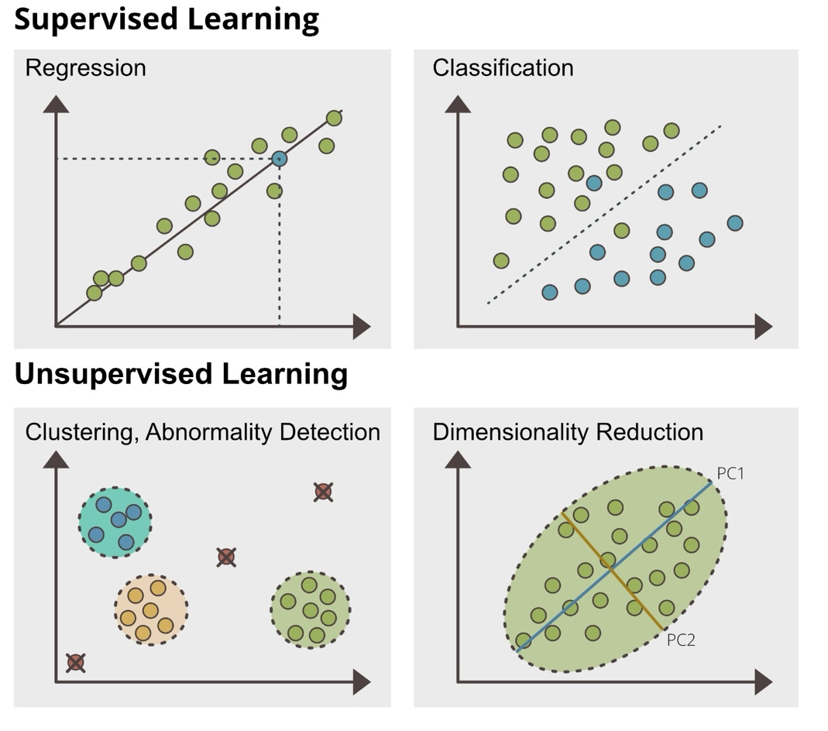
Fig.1. Different machine learning tasks by supervised (Regression/ Classification); and Unsupervised learning (Clustering/ Abnormality detection/ Dimensionality reduction)

Classical Regression Models
Classical regression models describe the relationship between input features and target variables using explicit mathematical functions, making them a foundational and highly interpretable class of supervised learning methods. In their simplest form, linear regression represents this relationship as a best-fit line in one dimension or a hyperplane in higher dimensions (Fig. 2a) [28]. In membrane fabrication, this allows researchers to relate processing variables directly to performance outcomes. The model estimates coefficients and an intercept by minimizing the sum of squared residuals between observed and predicted values. [29,30]. Because of its simplicity and interpretability, the linear regression is often used as a baseline for comparing more complex machine-learning approaches in membrane-fabrication studies.
Within this framework, researchers can utilize univariate architectures to predict a single target variable [31], or multivariate linear regression (MVR) architectures to predict multiple outcomes simultaneously [32]. MVR is particularly valuable in membrane science because physical properties are highly interdependent. For instance, a structural defect or a change in crosslinking density during synthesis will likely alter both water permeability and solute rejection simultaneously. By mathematically treating these responses as a joint architecture, MVR effectively captures this linked behavior and shared error.
For nonlinear response patterns, sigmoid regression provides a useful extension by mapping the linear predictor through an S-shaped function, which is well suited to bounded or saturating behaviors. This is particularly relevant when a membrane property changes gradually at first and then approaches a limiting value as processing conditions continue to vary. In contrast, logistic regression (Fig. 2a) is used for classification rather than continuous prediction, as it converts a linear combination of features into a probability of class membership. In membrane research, logistic regression can be applied to binary outcomes such as whether a membrane meets a performance threshold, whether a defect is present, or whether a fabrication condition is likely to produce an acceptable product. Its main advantage is that it remains interpretable while providing probabilistic predictions for discrete outcomes.

Regularized Linear Models
While standard linear models provide a highly interpretable baseline, membrane synthesis datasets often contain correlated parameters and limited sample sizes. Training models with a large list of features and limited samples will lead to models learning from the noise biased to the limited samples, which is also known as overfitting. To improve generalization, researchers use stepwise regression for variable selection (e.g. sequential backward selection (SBS)[33], recursive feature elimination (RFE)[34]), as well as regularized regression with L1 or L2 penalties[35,36].These methods help identify a compact set of fabrication parameters while keeping the model simple and robust.
Within this family, LASSO (Least Absolute Shrinkage and Selection Operator) is perhaps the most popular for membrane studies because it performs "automatic feature selection" (Fig. 2b). By applying a strict L1 penalty, it shrinks the weights of less important variables all the way to zero, effectively deleting them from the model. This leaves the researcher with a clear, concise list of only the most influential fabrication parameters. In contrast, Ridge regression (L2) reduces the impact of highly correlated variables without deleting them, while Elastic Net blends both approaches to handle groups of related conditions.
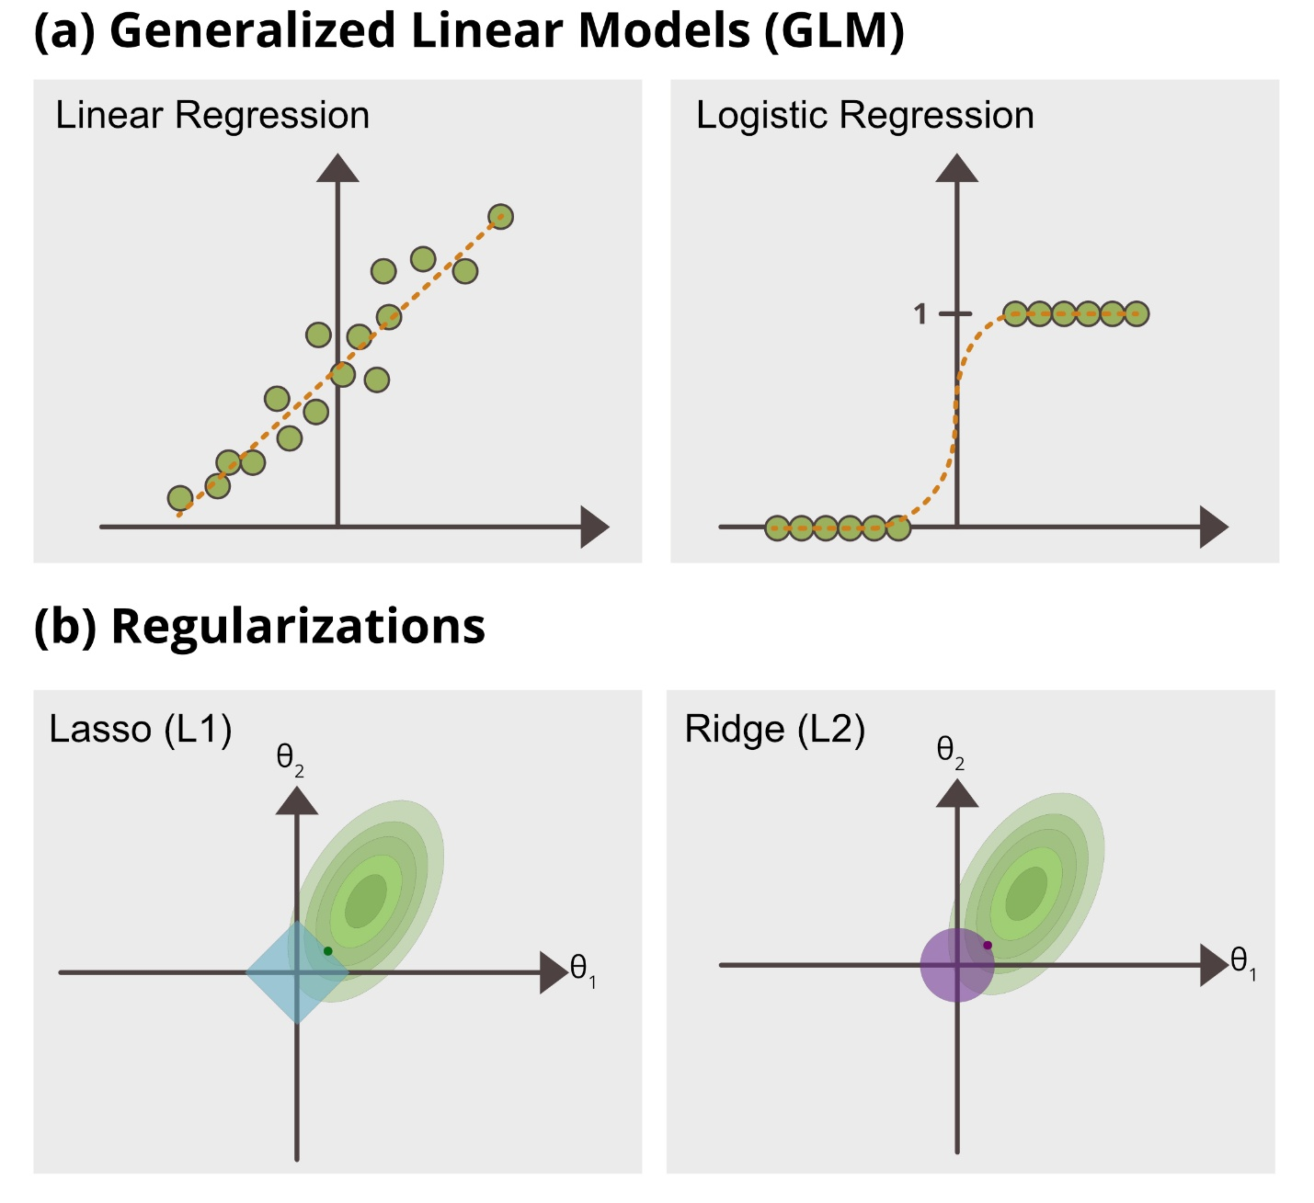
Fig.2. (a) Different GLMs used in membrane research; and (b) Regularizations used in GLMs

Distance and Probabilistic Models
Other traditional architectures include distance-based and probabilistic models. Distance-based methods, such as k-Nearest Neighbors (k-NN), predict membrane performance by comparing a new formulation with the most similar cases in the historical dataset, using feature proximity as the basis for inference. This makes k-NN intuitive and easy to interpret, particularly when similar processing conditions are expected to produce similar membrane properties[37]. However, its performance can be sensitive to feature scaling, noise, and the choice of distance metric, which may limit its robustness in high-dimensional membrane datasets.

Probabilistic Modelling
In contrast, probabilistic models such as Naïve Bayes estimate outcome probabilities from the observed distribution of input features under a conditional‑independence assumption, enabling efficient training and inference even when data are limited. This makes them attractive as fast baseline methods for categorical prediction tasks in membrane synthesis, for example predicting whether a given set of monomers and fabrication conditions will successfully form a separation film in interfacial polymerization systems [38,39]. Although simpler than many modern machine-learning approaches, these architectures remain useful when interpretability, computational efficiency, or rapid screening is prioritized.
Gaussian Processes (GPs) are another types of non-parametric probabilistic models that capture complex, non-linear relationships without relying on rigid equations [40,41]. Instead of a single "best-fit" prediction, a GP outputs a distribution of possible functions defined by a mean and covariance (kernel) function [40].
$$f\left(x\right) \sim GP\left(m\left(x\right), k(x, x^{'})\right)$$
For membrane scientists, the key advantage of this Bayesian approach is its built-in uncertainty quantification. By updating initial assumptions with experimental data, GPs generate empirical confidence intervals (or "error bars") that reveal the exact reliability of a prediction [41]. Gaussian Process Regression (GPR) applies this framework to continuous variables, estimating both the expected performance and its variance [42]. GPR is highly precise; for example, it outperformed SVR and RF in predicting flux (Willmott Index = 0.997) and rejection (WI = 0.613) for ceramic membranes treating oily wastewater [43]. To handle sharp physical data irregularities without mathematical "overshooting," researchers often use Matérn Gaussian Process Regression (MGPR). MGPR successfully simulated the sudden flux changes in thin-film composite (TFC) membranes before and after chlorination with 99% efficiency [40].
Beyond direct forecasting, this probabilistic nature makes GPs the ideal "surrogate model" for Bayesian Optimization (BO) [44]. By actively identifying regions with high uncertainty, GPs guide "active learning" to tell researchers exactly which experiments to run next, minimizing expensive lab trials. For instance, an MGPR surrogate efficiently mapped the structure-property relationships of roughly 70,000 covalent organic frameworks (COFs) for methane storage while intelligently navigating the underexplored design space [45].

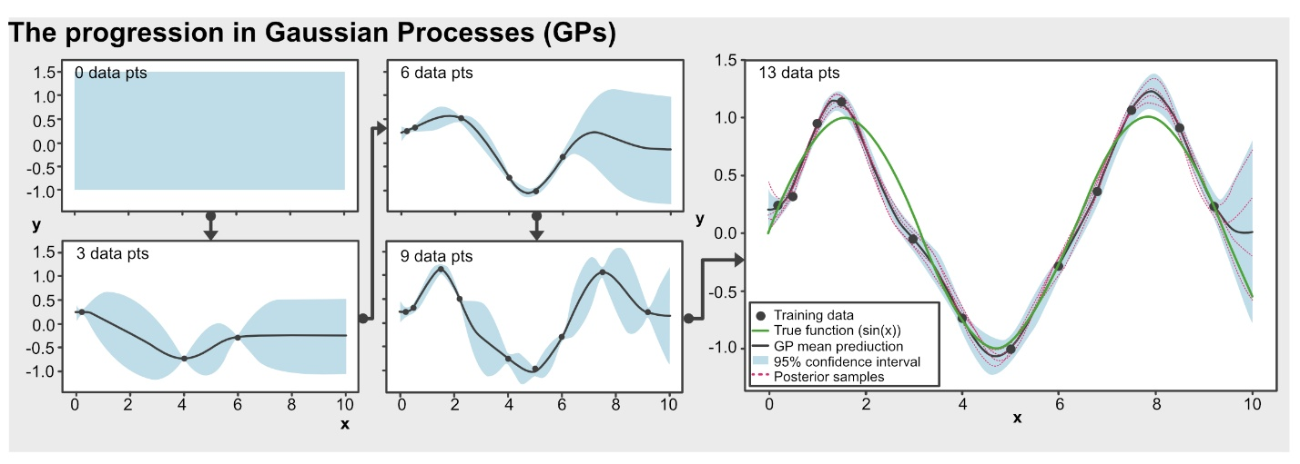
Fig. 6 Bayesian optimization and uncertainty reduction using Gaussian Processes. This progression visualizes how a GP fits a non-linear target function (y=sin(x)) Starting with a zero-mean prior, the algorithm sequentially adjusts its posterior distribution based on incoming training data, effectively demonstrating the reduction of epistemic uncertainty across the input space.

Artificial Neural Networks (ANNs)
Artificial Neural Networks (ANNs) are conventionally developed as purely data-driven computational models that learn input–output mappings through layers of interconnected mathematical functions (Fig. 5) [93], without requiring explicit mechanistic equations of the underlying system. A typical architecture consists of an input layer, one or more hidden layers that perform nonlinear transformations, and an output layer that produces the final predictions [41]. By iteratively adjusting internal weights and biases based solely on observed data (Fig. 5a), ANNs can capture complex relationships in high-dimensional spaces that are difficult to express in closed-form physical models [94].
In membrane research, Multi-Layer Perceptrons (MLPs) serve as the foundational neural network architecture for predicting performance metrics like salt rejection and permeation flux (Fig. 5b) [90,93]. Other specialized architectures are routinely deployed depending on the specific data modality; for instance, Recurrent Neural Networks (RNNs) are utilized to handle time-dependent operational datasets (Fig. 5c), while Convolutional Neural Networks (CNNs) are highly effective at processing spatial and visual data, such as membrane microscopy images (Fig. 5d). Sophisticated variants, such as multitask networks with skip connections and selectivity regularization, have even guided the fabrication of membranes that surpass empirical upper bounds [95]. Additionally, the Adaptive Neuro-Fuzzy Inference System (ANFIS) has been successfully used to model micropollutant removal and membrane distillation by blending neural learning with transparent, rule-based logic to maintain interpretability in uncertain systems [94,96].
Modern advancements have introduced further specialized architectures tailored to chemical and physical constraints. Graph Neural Networks (GNNs) and Graph Convolutional Neural Networks (GCNNs) are specifically designed to process non-Euclidean data, where information is represented as nodes and edges (Fig. 5e) [97]. This is particularly advantageous for modeling polymer backbones and molecular structures, where atoms and bonds are naturally abstracted as graphs [63]. By leveraging molecular fingerprints as graph inputs, GCNNs can establish structure-property relationships—such as predicting the fractional free volume (FFV) in polyimides—to accelerate the discovery of gas separation materials more efficiently than trial-and-error experiments [97].
Recently, Physics-Informed Neural Networks (PINNs) have emerged as a promising paradigm for membrane development. In this approach, neural networks are trained under explicit physical constraints by incorporating the governing equations (for example, partial differential equations) into the loss functional, thereby promoting predictions that are consistent with the underlying physics [41]. The conceptual framework and emerging applications of PINNs in membrane systems will be examined in detail in a subsequent section.

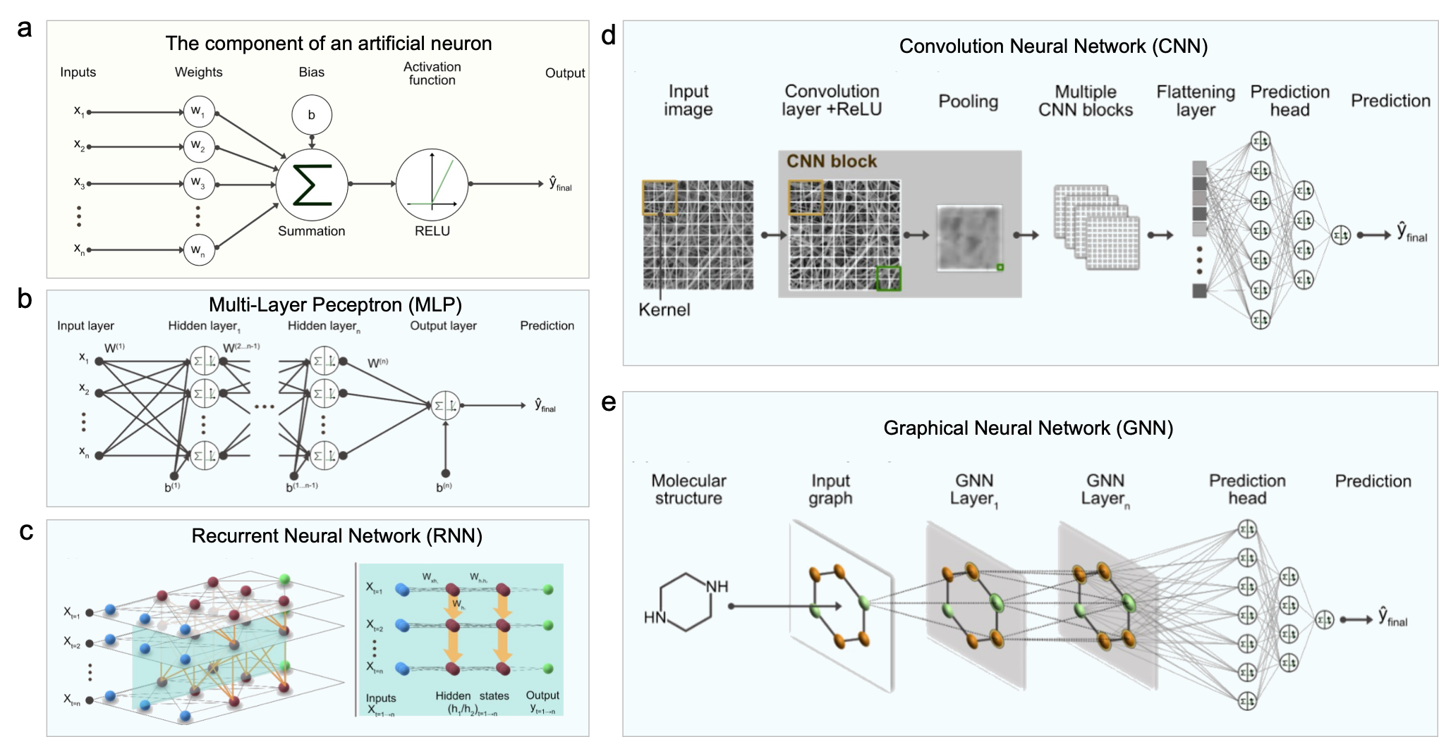
Fig. 5. Schematic representation of Artificial Neural Networks (ANNs) in membrane informatics: (a) Fundamental components of a single artificial neuron, and (b-e) common neural network architectures utilized in membrane research, where (b-e) are (b) Multi-Layer Perceptron (MLP), (c) Recurrent Neural Network (RNN), (d) Convolutional Neural Network (CNN), and (e) Graph Neural Network (GNN), respectively.

Margin-based Models
For more complex datasets where simple straight lines or basic probabilistic assumptions cannot adequately capture thermodynamic trends, Support Vector Machines (SVM), and their regression counterpart, Support Vector Regression (SVR), represent a distinct and highly mathematical class of margin-based models [93]. While the model still seeks an optimal hyperplane, SVR is unique in how it handles experimental error. It ignores small discrepancies that fall within a specific threshold, known as the ε-insensitive tube, and focuses only on the most difficult data points to predict, the "support vectors" [14].A key strength of SVM is the "kernel trick." This mathematically projects non-linear membrane data (where relationships are curved or grouped) into a higher-dimensional space where a flat, linear solution becomes possible [94]. Imagine trying to separate two types of mixed particles on a flat table; the kernel trick is like tossing them into the air so you can easily pass a sheet of paper between them at different heights.
Because they rely only on boundary data points rather than the entire dataset, Support Vector models are exceptionally memory-efficient and robust for the small datasets typically generated in laboratory settings. For example, SVR has been successfully utilized to model complex physical phenomena, such as predicting protein rejection in zeolite-based membranes [55] and mapping permeate flux in polyaniline-modified alumina membranes [11]. However, while SVMs are generally recommended for small to medium‑sized, well‑structured datasets, tree‑based ensembles such as random forests and gradient‑boosted trees are preferred for larger, more complex datasets due to better scalability and robustness.
Ultimately, due to their high interpretability, these linear and non-linear models are frequently used as comparison baselines to demonstrate fundamental physical trends (Table 1).

Category | Inputs → Outputs | ML Methods | Key Finding | Ref.
Supervised Learning
Gas separation | Connectivity indices → Tg, molar volume, O2 permeability/selectivity | RSML | Identified PMP & PPO as top air-separation candidates | [40]
Gas separation | Polymer fingerprint bits → log permeability (6 gases) | GPR | Found S/O/N motifs for CO2/CH4; 2 polyimides validated | [41]
Membrane characterization | PVDF conc, voltage, spinning distance → bead presence | XGBoost, SVM, MLP, LR | XGBoost best (~0.87/0.78 acc); polymer conc most important | [42]
Li extraction | Membrane/salt-rejection features → MWCO, permeability, Li/Mg selectivity | Linear/Ridge/LASSO, SVR, RF, etc. | R²=0.89; MgCl2 rejection most influential | [43]
Water treatment | Feed/permeate temp, flow, salinity → permeate flux (DCMD) | ANN, SVR, RF | ANN/SVR beat mechanistic model; feed temp key | [44]
Membrane characterization | PVDF conc, RED, chi, voltage, feed rate → fiber diameter | MLR, Ridge, Lasso, KNN, DT, RF, AdaBoost, GB, XGBoost | Feed rate dominant driver of fiber diameter | [45]
Water treatment | PIP/TMC/SLS conc, time → PWP, NaCl/Na2SO4 rejection | MLR, RF, MLP | RF best for PWP/NaCl; MLP best for Na2SO4 | [46]
Water treatment | Membrane/feed params → permeate flux | MLR, KNN, SVR, DTR, RFR, GBR, ERT, XGBoost | XGBoost best (R²=97.3%); feed temp/flowrate key | [47]
Water treatment | Pore radius, WCA, MWCO, zeta, feed conc, pressure → Li/Mg rejection, permeance | Linear/Ridge/LASSO, SVR, RF, ANN, PSO | Steric hindrance factors critical; PSO balanced tradeoffs | [48]
Gas separation (review) | SMILES/descriptors → gas transport performance | GPR, SVM, RF, ANN, DL, RNN, GA | Heteropolymers, inverse design, reliable datasets key | [10]
Gas separation | PLD, LCD, VSA, porosity → H2 permeability, TMSP / gas uptake-diffusivity | BPNN, SVM, RF, GPR, LASSO, Extra Trees, GB | GPR/RF or porosity descriptors dominant; transferable to MMMs | [49]
Water treatment | Pore shape/material/size, pressure, NaCl conc, charge → water flux, salt rejection | RF, XGBoost, PSO, GA | XGBoost strong; high-charge Ti3C2O2 confirmed by MD | [50]
Water treatment | Diamine fingerprints → water permeability | RF, CatBoost | SHAP-guided grafting raised flux 2.45→4.9 LMH | [51]
Water treatment | LbL fabrication params → permeability, selectivity | Linear, RF, Boosted tree, XGBoost | XGBoost best; 23 polymer candidates screened | [52]
Water treatment | Modification conditions → PWP, zeta potential (x2) | RF, GB, AdaBoost, ANN | Small datasets sufficient for reliable prediction | [53]
Water treatment | Nanoparticle properties → relative permeability/salt pass rate (x2) | Regression tree, AdaBoost, GBT, XGBoost | GBT best; NP loading dominant factor | [54]
Gas separation | Molecular descriptors/fingerprints → log gas permeabilities (6 gases) | RF, DNN | DNN ensemble best (R²~0.90); candidates above Robeson bound | [55]
Water treatment | Descriptors → ΔH‡, TΔS‡, ΔG‡ (anion permeation) | Linear reg, LASSO | Ion electrostatics dominate; poor extrapolation to sulfate | [56]
Biomedical | 12 peptide descriptors → AMP/non-AMP label | SVM | >90% blind-test accuracy; tracks membrane curvature not potency | [57]
Gas separation | Geometric/chemical MOF descriptors → CO2/N2 selectivity, permeability | RF | AV dominant for selectivity, gASA for permeability | [58]
Organic solvent separation | NP/monomer/solvent params → relative permeability/selectivity | Linear, SVM, Boosted tree, ANN | BT best; identified key fabrication factors | [59]
Water treatment | Chlorination conditions, membrane props → flux/rejection change | XGBoost | pH/chloride/O:N ratio key; moderate cross-linking helps | [60]
Membrane characterization | PLA/HKUST-1 wt%, casting params → thermal stability | DNN, linear/quadratic regression | DNN more accurate than regression models | [61]
Membrane characterization | PLA/HKUST-1 wt%, casting params → stress, strain, modulus, toughness | ANN | Good R² (0.93–0.97 interpolated) | [62]
Water treatment | Feed/coolant temp/flow, air gap, salinity → flux, GOR | Boosted trees, ANFIS | ANFIS best for flux; feed temp/salinity dominant | [63]
Water treatment | Reversible/irreversible resistance → oil/water separation efficiency | BPNN | MOF-5@PDA improved performance; BPNN predicted well | [64]
Water treatment | Membrane props → Lp, selectivity, trade-off coefficient | RF | Trade-off coefficient distinguished top membranes | [65]
Energy | AEM composition/props → current density | GBR, RF, LightGBM, XGBoost, CatBoost | CatBoost/RF best (R²=0.95/0.91); ion conductivity dominant | [66]
Energy | Polymer properties → proton conductivity, hydration number | LASSO, ANN, RF, XGBoost | RF: IECv is decisive parameter | [67]
Water treatment | Thickness, cation radius, time → relative resistivity | ANN | Shallow ANN predicted well; used for rejection mapping | [68]
Energy | Feature set → ion conductivity at 80°C | GPR, SVR, RF, ANN | FCNN best fit; led to anilinium-based AEM design | [69]
Water treatment | Size ratio, charge product, zeta, WCA, logD → OMP rejection | MLR, SVM, XGBoost | XGBoost best; size exclusion & electrostatics key | [70]
Water treatment | Monomer fragments + fabrication → permeance, rejection (x2) | Linear reg, KNN, DT, LightGBM, XGBoost, CatBoost | CatBoost best; membranes with high permeance & rejection found | [71]
Water treatment | GO/POSS content, salinity, pressure → contact angle, salt rejection, flux | ANN | R²=0.918–0.959; balanced optimal condition identified | [72]
Gas separation | Fragment vectors + fabrication → CO2 permeability/selectivity | RF, ANN, GNN | Fragment RF best; PEO membranes above Robeson bound | [73]
Gas separation | Polymer/MOF properties → He permeability/selectivity in MMMs | DT, RF, LightGBM, XGBoost | XGBoost best; transferred well to hMOF/polymer MMMs | [74]
Organic solvent separation | Solute + solvent structure → solute rejection | GNN, PLS | Solvent structure improves prediction; key solvent descriptors found | [75]
Organic solvent separation | Thickness, WCA, viscosity, fingerprints → log10 solvent permeability | KRR, GBR, LASSO | PIM-A1 identified & validated experimentally | [76]
Organic solvent separation | Layer thickness, solvent props → solvent permeance, solute rejection | GBR | R²=0.95/0.68; new high-permeance membranes found | [77]
Water treatment | Monomer/polymer/process descriptors → acetic acid/H2O separation factor | SVR, GPR, RF, XGBoost, CatBoost | CatBoost best; mass ratio most important predictor | [78]
Environmental sensing | CV currents → ethanol concentration | SISSO | Simple equation enabled accurate ethanol quantification | [79]
Water treatment | Pressure, volume(, concentration) → flux, rejection | RF, SVR, GPR, SVM, DT | GPR generally best for flux prediction | [80]
Water treatment | MaxP, MinP, MW, CS → micropollutant rejection | ANFIS, LR, SLR, MVR, SVM, boosted trees | NF-GP model best (R²=0.965) | [81]
Water treatment | Descriptors → flux before/after chlorination | GPR | NSE ~99%, strong accuracy | [82]
Water treatment | Membrane/pore properties → water flux, salt rejection, charge | XGBoost, DT | XGBoost gave minimum prediction errors | [83]
SUPERVISED, SEMI-SUPERVISED / MULTITASK / TRANSFER / PHYSICS-INFORMED / BAYESIAN OPT / HUMAN-IN-LOOP —
Gas separation | Polymer graph/SMILES descriptors → gas permeabilities (5 gases) | GREA, SGIR, GCN, GIN, RF, GPR, MLP | Polyimides exceeding 2008 upper bound found; rigidity/free volume key | [84]
Gas separation | Polymer SMILES + selector vectors → gas permeability/diffusivity/solubility | GNN | R² improved 0.93→0.96 across 13 polymer classes | [85]
Water treatment | Immersion time, PIP/SDS/TMC conc → permeance, multi-salt rejection | ANN, SVR, XGBoost, RF | Multitask MLP beat single-task; membranes beat upper bound | [86]
Not reported | Polymer SMILES graphs → up to 36 polymer properties | GNN (polyGNN) | Faster than handcrafted features; comparable/better accuracy | [87]
Organic solvent separation | Polymer/solvent fingerprints → solvent diffusivity, sorption uptake | GPR, ANN | Found PVC & halogen-free alternatives | [88]
Water treatment | Molecular/membrane descriptors → HMP rejection | RF, XGBoost, LightGBM, CNN, Transformer, ANN | XGBoost best; ΔGs-m dominant determinant | 88
Water treatment | DFT + fabrication params → permeance, dye/salt rejection | XGBoost, CNN, Bayesian opt | XGBoost > CNN; fabrication dominant for permeance | 89
Water treatment | Monomer fingerprints + fabrication → water permeability, salt rejection | XGBoost, CatBoost, Bayesian opt | Test R²=0.78/0.84; Bayesian opt found exceeding combos | 90
Gas separation | MOF structural descriptors → gas uptake/diffusion | LASSO, Extra Trees, GB, RF | Porosity more critical than chemistry; transferable to MMMs | 91
Organic solvent separation | Solvent molar volume, chemical features → sorption uptake, diffusion coefficient | NN, Physics-informed NN | Predicted mixture permeation; extrapolated to unseen polymers | 92
SUPERVISED + UNSUPERVISED
Membrane characterization | SEM images → elastic modulus | CNN, YOLO | SEMPro predicted modulus within same order of magnitude | 93
Membrane characterization | Electrospinning params (3 case studies) → fiber diameter | LW-KPLSR, LSSVR, PCR, PLSR, Fuzzy, PCA | LW-KPLSR best (R²=0.9989) | 36
Membrane characterization | SEM feature vectors (AE) → nanofiber class labels | AE, MLP, SVM, LDA | AE-MLP best (92.5% accuracy) | 94
Water/organic solvent (review) | Membrane/solvent/solute descriptors → various separation metrics | ANN, SVM, DT, LASSO, PCA, GPR, GNN, GAN | ML predicts performance & optimizes conditions; liquid separation studies still limited | 95
Water treatment | Various databases → contaminant removal, flux, fouling | AdaBoost, ANN, RNN, CNN, SVR, etc. | ANN most-used algorithm; recommends hybrid ML approaches | 5
Water/gas/ energy | Membrane materials/structures → selectivity, permeability, flux, fouling | ANN, DNN, LSTM, CNN, SVM, RF, GPR, PCA | ML broadly improves membrane performance/efficiency; data/interpretability key barriers | 96
Water treatment | DFT descriptors + fabrication → permeance, dye/salt selectivity | XGBoost, CNN, Bayesian opt, t-SNE | XGBoost > CNN; upper-bound-breaking selectivity for dye recovery | 89
UNSUPERVISED LEARNING (pure)
Gas separation | Temp, pressure, thickness, H2 flux → PCs, clusters | PCA | Revealed variable interdependencies; 4 membrane clusters | 97
Water treatment | Fabrication/characterization variables → PCA clusters | PCA | Fabrication strongly affects membrane characteristics | 98
Water treatment | DAE-discretized data → latent-state reconstruction | Autoencoder-decoder, MLP | Learned observer: <1% error, finite-time convergence | 99
— ACTIVE LEARNING —
Water treatment | Pore radius, zeta, pressure, feed conc → salt permeation, dye rejection | RF, XGBoost, GPR | XGBoost outperformed RF; pore radius/zeta dominant | 100
— MULTI-PARADIGM REVIEWS (broad combos) —
Gas/water/ energy | Structural/environmental descriptors → separation performance | XGBoost, RF, ANN, SVM, PINN, SISSO | ML identifies key descriptors; liquid separations limited by data scarcity | 101
Gas separation | Experimental/simulation data → membrane properties | SVM, DT, GPR, ANN, RF, clustering | ML accelerates screening but still early-stage | 102
Gas separation | Material properties → gas permeability/selectivity/stability | GPR, SVM, RF, CNN, GNN, XGBoost | ML screens materials; data/interpretability challenges remain | 38
Water/gas/ organic | Various polymer/membrane descriptors → various performance metrics | ANN, GPR, GB, XGBoost, CNN, CatBoost | Summarizes ML in membrane design; datasets/featurization remain challenges | 103
Water/gas/organic/energy | Not reported → Not reported | Broad ML list | Proposes ideal AI-aided membrane development paradigm; data scarcity a key limitation | 40
Not reported | Material design params → material properties/structures | VAE, GAN, ANN, GNN, GPR | ML reduces design-space dimensionality; accelerates inverse design
Not reported | Various descriptors → various | Broad ML list | Predictive models dominate; generative design underexplored
Not reported | — | Broad ML list | Summarizes ML-driven material discovery workflow
Energy | Operating/catalyst descriptors → voltage, efficiency, degradation, RUL | Linear, ANN, DNN, SVM, LSTM | Cost/durability major barriers; physics-informed learning proposed | 104
Water treatment | Process params → desalination performance metrics | ANN, RBFNN, RNN/LSTM, SVM, RF, ANFIS, RSM | ANN/RSM most used; data scarcity major challenge | 105
— BAYESIAN OPTIMIZATION / INFERENCE —
Energy | Operational params, i-V curve → polarization curve, PPD | MCMC, XGBoost, RF, SVR, ANN | XGBoost best; identified key PPD correlations | 107
— GENETIC ALGORITHM-BASED OPTIMIZATION —
Gas separation | Linker/metal salt/modulator conditions → synthesis fitness (XRD) | Genetic algorithm | Optimized SURMOF synthesis; H2/CO2 above Robeson bound | 108
— DEEP GENERATIVE MODELING —
Not reported | Microstructure images/voxels → generated microstructures | DDPM, DDIM | Reconstructed diverse microstructures; extended to 3D with permeability control | 109
Not reported | 2D microstructure images → 3D microstructure volumes | DDPM (Micro3Diff) | Reconstructed 3D structures preserving connectivity/statistics
Table 1. Extracted Information from Machine Learning Membrane Papers

Tree-based models
Tree-based models partition data through hierarchical if-then rules and are well suited to capturing nonlinear relationships in membrane fabrication. A decision tree is the most basic tree-based model, which begins at a root node, splits data into branches based on feature tests, and ends at leaf nodes that give the final prediction (Fig. 3). This structure is easy to interpret and resembles a laboratory decision flowchart. Tree-based models are exceptionally well in handling high‑dimensional, mixed (continuous and categorical) features; while not necessarily to normalize or scale features prior to modelling. In membrane research, decision trees are useful for handling mixed experimental variables and capturing nonlinear trends without requiring strong assumptions about data form. [94,98].
Decision trees provide an intuitive baseline, while ensemble methods such as Random Forest and Gradient Boosting usually offer better predictive performance and robustness. Random Forest reduces variance by averaging many independent trees, whereas Gradient Boosting builds trees sequentially to correct previous errors.
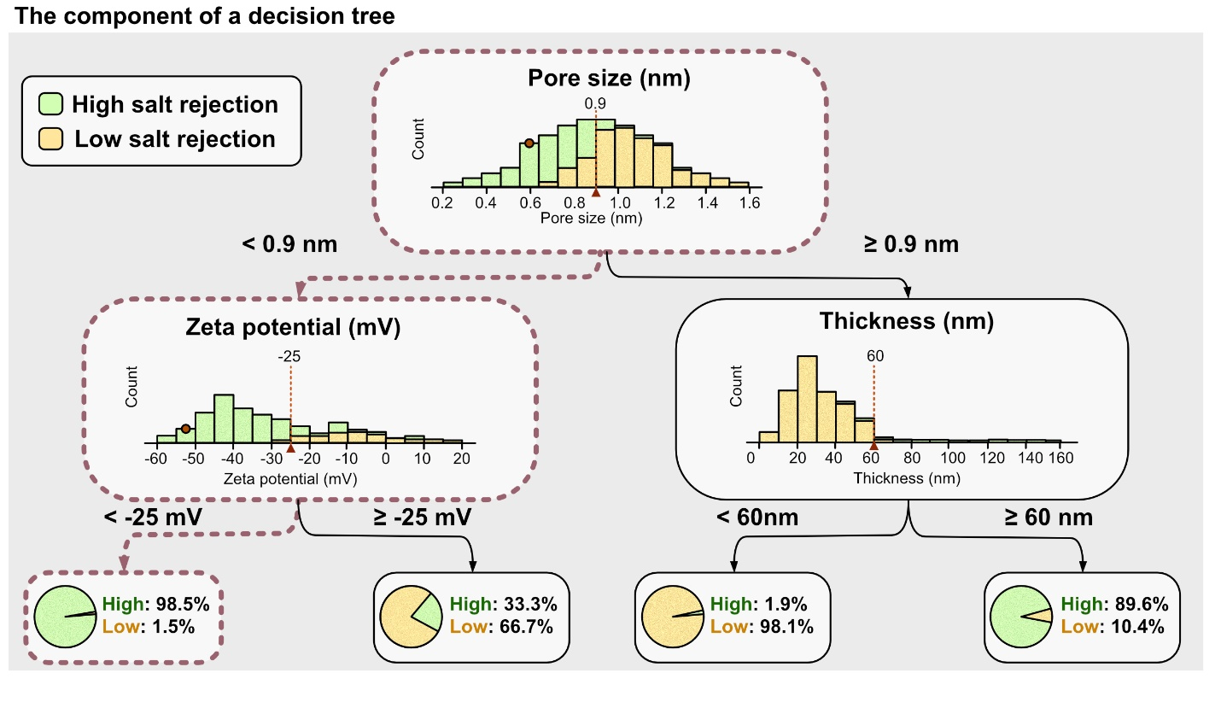
Fig. 3.Decision tree architecture and feature splitting. An illustrative example showing how continuous variables are partitioned by a tree-based classifier. Each internal node represents a feature test (e.g., pore size ≥ 0.9 nm), leading to downstream branches and final leaf nodes that quantify the percentage distribution of the target classes.
    - Ensembled Models
Ensembling is a broader strategy that combines multiple base learners to produce a stronger and more stable predictor. Although ensemble methods are most closely associated with decision trees, the concept can also be applied to linear models, distance-based methods, and neural networks. By aggregating predictions from multiple models, ensembling can reduce the impact of noise and improve generalization on limited experimental datasets.
In membrane science, these ensemble frameworks are typically executed via three primary strategies (Fig. 4). Bagging (Bootstrap Aggregating) constructs independent base models in parallel and averages their predictions to reduce variance and improve stability (Fig. 4a). While applicable to various base algorithms, it is most heavily utilized in membrane research through tree-based models like Random Forest (RF) and Extra Trees [54,63,93]. Boosting, conversely, builds models sequentially (Fig. 4b). Each new algorithm is specifically trained to mathematically correct the residual errors of its predecessor. Prominent boosting frameworks, including XGBoost, LightGBM, CatBoost, and AdaBoost, are highly effective at mapping complex, non-linear membrane synthesis variables [5,94,99]. Finally, Stacking takes a hierarchical approach by training multiple diverse base models and then using a secondary "meta-model" to combine their predictions into a single, highly accurate final output (Fig. 4c) [45,100].
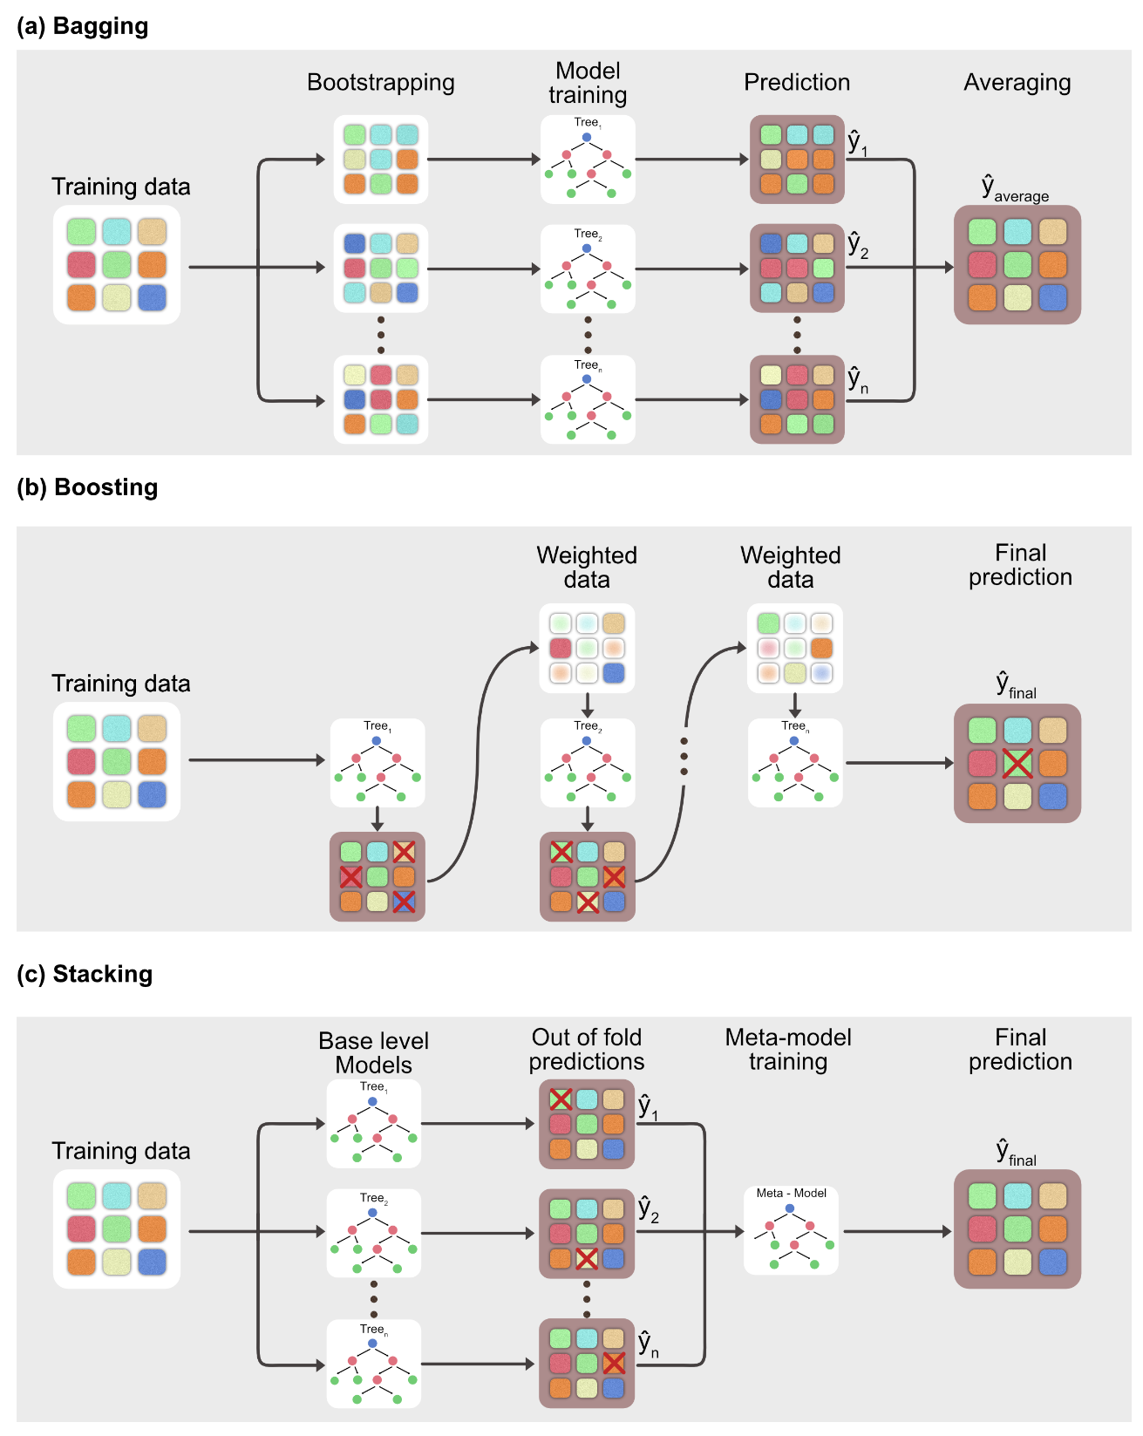
Fig. 4. Schematic representation of tree-based architectures in membrane informatics: (a) Bagging (b) Boosting, and (c) Stacking.
Because ensemble methods combine dozens or hundreds of base algorithms, they introduce a high degree of architectural complexity. To prevent these ensembles from becoming computationally inefficient or overfitting the training data, rigorous hyperparameter tuning is essential. Researchers must carefully optimize internal settings, such as the total number of estimators, learning rates, and individual model constraints.
To navigate this complexity without relying on manual trial-and-error, researchers increasingly deploy automated optimization frameworks. For example, the Tree-based Pipeline Optimization Tool (TPOT) utilizes genetic programming to autonomously handle both feature engineering and hyperparameter tuning [101,102]. By mathematically evolving the best model parameters, this automated tuning approach has successfully outperformed traditionally configured models when screening the performance of COF and MOF membranes [44,55]. The specific trade-offs for these architectures are detailed in Table 2.
Table 2. Comparison of Machine Learning Algorithms by Accuracy and Extrapolation Potential
Algorithm | Key Mechanisms | Generalization / Extrapolation Potential | Primary Accuracy Concerns
Linear Models | Continuous targets prediction through optimized weighted-sum functions between input features and outputs. | Low to Moderate: highly interpretable and stable when membrane structure-property relationships are approximately linear. Regularization [LASSO / Ridge / Elastic Net], feature selection [Stepwise / SLR], and multi-response modelling [MVR] improve stability on high-dimensional, multicollinear, or coupled-output datasets, while polynomial or kernelized extensions [KRR] provide limited nonlinear capacity. | Poor or suboptimal accuracy when nonlinear fabrication-property relationships dominate.
Support Vector Machine | Boundary-fitting based on the most informative samples, support vectors. | High: suitable for small datasets involving complex nonlinear mappings and high-dimensional feature spaces. Controlled margin violation enables certain generalization ability; and kernel mapping enables certain nonlinearity. | Depends on intensive hyperparameter tuning and may suffers on unbalanced datasets or very large datasets. Performance is not consistently superior in membrane studies.
K-Nearest Neighbours | Inference from stored training samples in the feature space. | Very Low: relies strictly on local similarity between existing data points and possesses minimal extrapolation ability. | Sensitive to distance metrics, feature scaling, neighbourhood size, noise, and sparse high-dimensional data; lacking of explicit global mapping.
Gaussian Process | Prediction as a Bayesian distribution over possible functions, defined by a mean function and covariance, estimating both predictive mean and variance. | Excellent for uncertainty-aware exploration: useful when membrane or material design spaces are underexplored, because it predicts both target values and uncertainty. Nonlinear smoothness can be adjusted through kernel design, and overshooting or oscillation can be reduced by using kernels with more flexible smoothness assumptions [MGPR]. | Depends strongly on whether the selected mean/covariance functions and smoothness assumptions match the underlying structure-property relationship.
Artificial Neural Networks | Complex nonlinear mappings through layer-wise transformations with trainable weights, biases, and activation functions. | High: flexible in capturing intricate nonlinear relationships within high-dimensional membrane data. Generalization can be strengthened when the architecture matches the data structure, such as physical equations for physics-constrained systems [PINN], fuzzy rules for uncertain systems [ANFIS], spatial extraction for image-like data [CNN / ResNet], or graph topology [GNN / GCNN] for molecular and polymer structures. | Depends strongly on data size, architecture design, and training strategy. Complex architectures require suitable data representations and may not generalize well if the training data do not cover the target chemistry, morphology, or operating conditions.
Tree-based Models | Prediction by hierarchical feature-space partitioning, then strengthened through variance-reducing aggregation or residual-correcting boosting. | High to Excellent: nonlinear membrane structure-property relationships can be captured without prior feature scaling through interpretable decision partitioning [DT]. Stability on small or noisy datasets can be improved by aggregation and randomization [RF / Extra Trees], while tabular accuracy can be strengthened by sequential residual correction and regularized boosting [GBoost / LightGBM / XGBoost / AdaBoost / CatBoost]. Pipeline optimization [TPOT] further supports feature engineering and hyperparameter tuning. | Individual trees overfit easily, and ensemble accuracy depends on tuning, noise, and dataset sparsity. Complex ensembles can become black-box models, and split-based predictions may have limited smooth extrapolation outside observed design regions.

The application of tree-based algorithms in membrane research spans from the molecular design of new materials to the optimization of large-scale fabrication and process conditions. Because they effectively capture non-linearities and interactions between fabrication variables without requiring extensive data pre-processing, tree-based algorithms have emerged as the most versatile and capable class of models for direct input-output relationship projection tasks. As evidenced by the comparative performance data in Table 1, these models frequently serve as the high-accuracy benchmark against which other supervised learning methods are measured. By leveraging the specific strengths of the diverse frameworks detailed in Table 2, researchers can select the optimal ensemble strategy—whether prioritizing the stability of Random Forest for small lab datasets or the high-performance predictive power of XGBoost for material screening.

Unsupervised Learning Algorithms
Unsupervised learning autonomously discovers intrinsic structures within unlabelled datasets by identifying latent similarities without predefined labels [41]. In membrane-machine-learning projects, unsupervised learning is most often used in preprocessing and exploratory analysis, particularly for data visualization, dimensionality reduction, clustering, and similarity-based identification of redundant samples. While still less prevalent than supervised methods, its importance is growing as researchers seek to navigate high-dimensional combinatorial design spaces that are difficult to explore through conventional trial-and-error approaches. [63,94].

Dimensionality Reduction: Visualizing the Material Space
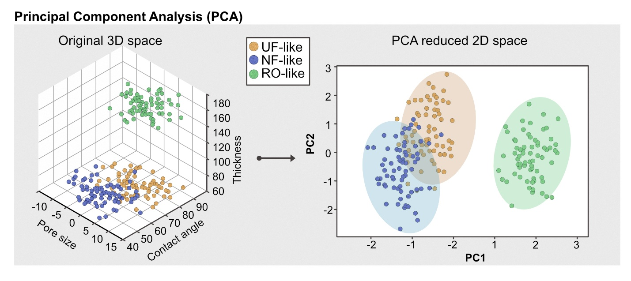
Fig. 7. Dimensionality reduction via Principal Component Analysis (PCA). This example shows the transformation of a 3D physical property dataset into a simplified 2D coordinate system. By capturing the axes of maximum variance, the first two principal components (PC1 and PC2) successfully retain the underlying group separations among the UF-like, NF-like, and RO-like membrane types.
Dimensionality reduction provides solutions for data compression and exploratory analysis by simplifying the "feature space" of membrane fabrication [82,97]. The primary tool for this is Principal Component Analysis (PCA), which reduces high-dimensional variables into a smaller set of uncorrelated principal components (PCs) [95]. By prioritizing directions of maximum variance, PCA filters out experimental noise to reveal simplified hidden structures [94].
In practice, PCA allows researchers to uncover interdependencies between fabrication conditions and performance that are often obscured in traditional analyses. For example, it has been used to identify synergistic relationships between temperature and permeability in palladium composites [103] and to map how chemical composition dictates membrane characteristics [104]. Furthermore, PCA serves as an essential feature engineering tool; researchers have successfully compressed 18 organic solvent nanofiltration (OSN) parameters into a reduced subspace to improve dataset coverage and standardize predictive models like ANN and RF [94].

Clustering: Categorization and Space Navigation
While dimensionality reduction helps visualize data, clustering and semi-supervised learning (SSL) focus on categorizing materials and navigating vast design spaces where experimental data is scarce [105,106]. Clustering algorithms, such as k-means, Hierarchical Clustering and DBSCAN and its variants, group unlabeled data points based on spatial proximity and mathematical similarity within a high-dimensional feature space of fabrication descriptors. In membrane informatics, these unsupervised frameworks are first utilized for critical dataset curation . For example, as researchers aggregate large-scale literature records for centralized repositories like the Open Membrane Database (OMD), they frequently encounter severe data redundancy from repeated baseline formulations [56,99]. Clustering architectures offer a mathematically rigorous method for dataset deduplication by flagging data points with near-zero spatial distances as redundant formulations. Isolating and collapsing these identical records ensures a balanced data distribution, preventing downstream supervised models from overfitting to over-represented regions [42,63]. Beyond data cleaning, clustering serves as an unbiased tool to uncover optimized manufacturing regimes. Once independent clusters are formed based purely on fabrication parameters, researchers can retroactively overlay performance metrics, such as water permeance or solute rejection, onto the groups. This post-clustering analysis helps identify localized "clusters of excellence," revealing hidden thermodynamic "sweet spots" within complex, multi-variable design spaces [93].

Physics-Informed Machine Learning (PIML): The "Grey Box" Approach

Hybrid Modelling: From Edisonian Trials to Physics-Informed Frameworks
Historically, membrane material development and separation-process optimization relied heavily on iterative trial-and-error experimentation, often described as the Edisonian method [62]. This empirical strategy is increasingly viewed as inadequate given the staggering complexity of the chemical space available for polymer synthesis and the multi-scale nature of transport phenomena in complex fluids [44]. To address these challenges, mechanistic “white-box” models, such as the Donnan Steric Pore Model with Dielectric Exclusion (DSPM-DE) and solution-diffusion-friction models, provide high physical interpretability but depend on numerous simplifying assumptions [100,107]. These simplifications often lead to failure in model generalization when encountering new operating conditions or complex, multi-component feedwaters, and their calibration often requires detailed characterization and extensive parameter estimation [45,98,107].
In parallel, data-driven “black-box” models have become increasingly attractive because they can learn highly nonlinear relationships directly from experimental and literature data [45]. While these models excel in interpolation where data is abundant, they lack inherent physical governance. In data-scarce regimes, they can produce predictions that violate thermodynamic laws or mass conservation, making them unreliable for safety-critical systems like industrial membrane reactors [44,62,105]. To mitigate this, interpretability frameworks like SHapley Additive exPlanations (SHAP) are utilized to identify paramount determinants for performance. By quantifying the influence of fabrication parameters (e.g., monomer concentration, curing time) and membrane properties (e.g., pore size, surface zeta potential) on performance metrics like water permeance or degradation, SHAP assists in the rational design of membranes [54,94,95,108].
Taken together, these limitations have driven increasing interest in grey-box models, or the Physics-informed models[109,110], which seek a balance between mechanistic rigor and data-driven flexibility. Rather than relying solely on fixed physical equations or purely empirical fitting, grey-box frameworks embed known physical laws into machine-learning architectures and use data to learn unknown residual behavior. This makes them especially attractive for membrane science, where datasets are often small, transport behavior is strongly nonlinear, and both physical insight and robust prediction are needed. In this context, grey-box modeling offers a practical compromise that retains the interpretability of white-box models while gaining much of the adaptability of black-box approaches.
Figure 8 therefore illustrates the conceptual transition from traditional mechanistic and data-driven models toward hybrid frameworks, highlighting the role of explainable artificial intelligence in moving fully data-driven models toward a more transparent paradigm. The contemporary research landscape is now defined by the pursuit of "grey-box" models, which hybridize the inductive power of machine learning with the deductive rigor of physical laws resolving the historic modeling dilemma between purely mechanistic and purely data-driven approaches [45,63] (Fig. 9a). The primary paradigms of this shift are compared in Table 3 below.
Table 3. Comparison of different modeling paradigms in Physics-Informed Machine Learning (PIML).
Modeling Paradigm | Physical Governance | Mechanism of Action | Data Dependency | Extrapolation Capability
Mechanistic (White-Box) | Complete Governance | Explicit physical laws and PDEs | Very Low (Requires parameters) | Very High (Based on physics)
Data-Driven (Black-Box) | None (Purely Statistical) | Statistical pattern recognition | High (Requires large datasets) | Poor (Limited to training range)
PINN (Grey-Box) | Soft Constraints | Embedding PDEs into loss functions | Moderate (Supports sparse data) | High (Guided by equations)
PENN (Grey-Box) | Hard Constraints | Architectural prior integration | Low to Moderate | High (Guided by structural priors)

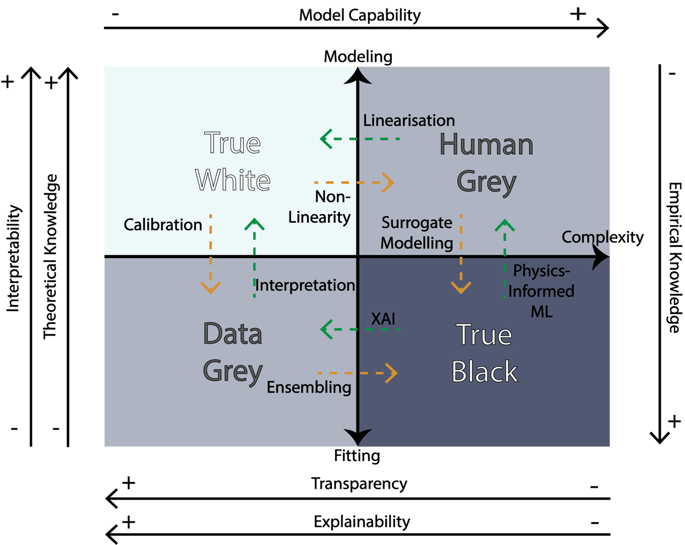
Figure 8. A dual-axis conceptual framework detailing the relationship between model interpretability, theoretical knowledge, and empirical complexity. The diagram illustrates how the application of eXplainable AI (XAI) and interpretability frameworks (such as SHAP) facilitates the transition of purely data-driven "True Black" models into a more transparent "Human Grey" paradigm, enhancing physical governance without sacrificing statistical predictive power.
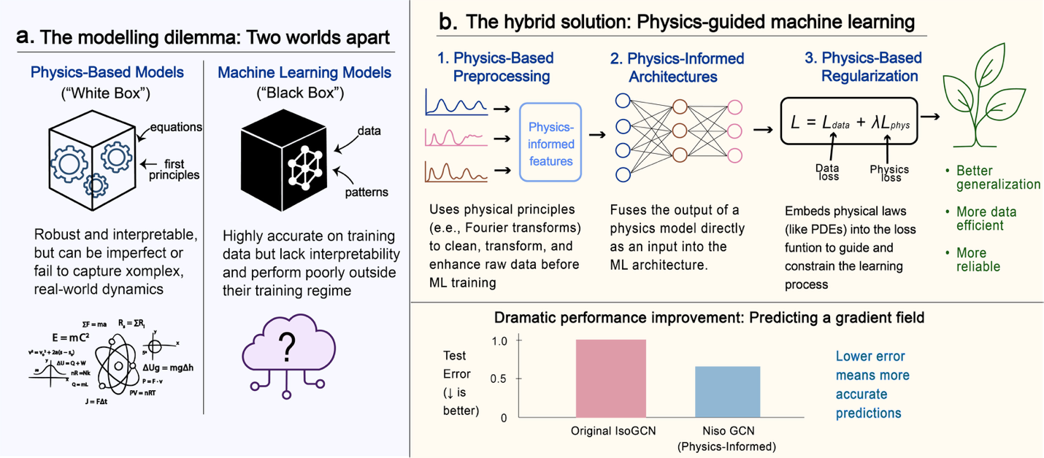
Fig.9. The Physics Guided Machine Learning framework. (a) The modeling dilemma between mechanistic and data driven approaches. (b) The three-stage hybrid solution comprising physics-based preprocessing, physics informed architectures, and regularization to achieve superior predictive accuracy and reliability compared to traditional baselines.

Constraints: Encoding Physics into the Machine Learning Pipeline
PIML encodes physics into different stages of the model-training pipeline, beginning with physics-informed feature engineering. In this approach, the feature set is enriched with physical and chemical descriptors that are relevant to the prediction task, for example by extracting monomer properties such as viscosity and surface energy from databases. Raw variables can also be transformed into nondimensional groups, such as Reynolds or Péclet numbers, symmetry-preserving invariants, or conservation-based aggregates [41,42,45]. This strategy constrains learning to a physically meaningful representation, which can improve sample efficiency and promote smoother mappings that generalize better across different operating conditions.
Building upon this, Physics-Informed Neural Networks (PINNs) represent a paradigm-shifting approach by using physical laws as soft constraints during optimization [41,97]. PINN utilizes a neural network as a universal function approximator to solve ordinary or partial differential equations (ODEs/PDEs) governing membrane systems, such as the Nernst-Planck or Navier-Stokes equations. Unlike traditional networks, a PINN minimizes a composite loss function:
$L= w_{data}L_{data}+w_{phys}L_{phys}+w_{bc}L_{bc}+w_{ic}L_{ic}$
where the unsupervised "physics loss" term (L_{phys}) penalizes deviations from underlying governing laws evaluated at collocation points, while L_{bc} and L_{ic} enforce boundary and initial conditions as soft constraints [41,45,111]. By utilizing automatic differentiation (AD) to compute exact derivatives, PINNs eliminate the need for the elaborate mesh generation required in traditional finite element methods (FEM) [94,96]. This mesh-free nature is highly beneficial for capturing sharp gradients in concentration or potential fields within complex domains, such as RO module feed spacers or the intricate pore networks of nanofiltration membranes [44,95].
Finally, Physics-Enhanced Neural Networks (PENNs) apply hard constraints through deep structural integration. Instead of relying on loss function penalties, PENNs explicitly encode known theoretical equations as the final layer of the network. This framework is remarkably effective for modeling material properties such as membrane thickness degradation or polymer melt viscosity [41,54,112]. For example, a PENN might utilize a neural network to predict the empirical parameters for the Arrhenius or Williams-Landel-Ferry (WLF) equations, which are then processed through a fixed physical layer [62]. This guarantees that the output strictly follows correct temperature and molecular weight dependencies by design, providing extreme data efficiency even when datasets are limited [45,90,94]. Taken together, physics-informed feature preprocessing, soft optimization constraints, and hard architectural integration constitute a unified, multi-stage hybrid workflow that ensures rigorous physical consistency across data-sparse regimes (Fig. 9b).

3. Data and Infrastructure: The Experimentalist’s Toolbox and Materials
While model architecture influences pattern extraction, predictive performance in membrane science is fundamentally limited by the fidelity, coverage, and consistency of the underlying data. Cross-laboratory variability in measurement protocols introduces significant uncertainty, as nominally identical properties may be quantified using techniques with different sensitivities, calibration standards, and detection limits. For instance, salt rejection measured by conductivity, ion chromatography, or ICP is not directly interchangeable and can introduce systematic bias if treated equivalently.
Further limitations arise from incomplete coupling between composition, processing, and structure. Identical chemistries can yield markedly different membrane morphologies and transport properties depending on fabrication conditions, such as interfacial polymerization parameters or post-treatment steps. Without explicitly capturing these relationships, models risk learning spurious correlations rather than physically meaningful trends. Addressing these challenges requires rigorous data curation, standardized measurements where possible, and representations that encode both material chemistry and fabrication history.
As the field shifts toward data-driven discovery, machine learning models must integrate heterogeneous data sources, including structured descriptors, imaging data, simulation outputs, and operational time-series [9,12,113]. The following sections examine these data types, focusing on their extraction, featurization, and integration into predictive and generative models.

Structured Tabular Data
Tabular data serves as the building block of membrane informatics, representing the primary format for reporting experimental outcomes, synthesis recipes, and standardized performance metrics in the scientific literature and commercial datasheets. The utility of tabular data lies in its ability to condense complex experimental conditions into a structured format suitable for traditional machine learning algorithms that have been discussed in the previous section [114,115].
Tabular data for membrane usually consists of features consisting of membrane compositions (e.g. monomers and solvents), additives (e.g. conductivity enhancer, surfactants) and fabrication conditions (e.g. different membrane fabrication techniques used and their settings), with targets ranged from membrane properties (e.g. pore diameters, porosity) and performance (e.g. permeability, salt rejection). At the molecular level, one notable featurization method is the extraction of chemical structures from membrane components represented in the Simplified Molecular Input Line Entry System (SMILES). In membrane science, this often involves the use of hashed fingerprints that integrate monomer chemistry and topological information [13] Researchers have successfully utilized Gaussian Process Regression (GPR) models trained on these hashed fingerprints to predict the gas permeability of over 11,000 polymers [97,116].
Another critical featurization strategy is the group contribution approach, where polymeric materials are represented as combinations of multiple repeating units or functional groups, each assigned a numerical descriptor. This allows machine learning models to learn the non-linear contributions of specific chemical moieties to the membrane's macroscopic properties, such as glass transition temperature or pure water flux. For example, in the study of polyimides, a dataset of 1,261 unique structures was used to construct quantitative structure-property relationships (QSPR), with Categorical Boosting (CatBoost) models achieving an R² of 0.895 for the test set [49].
Currently, most reported datasets are tabular data curated from in-house experiments or extracted from historical literature, and increasing effort is put on the creation of open repositories storing such data. One major milestone in the centralization of tabular membrane data is the Open Membrane Database (OMD), an international, crowd-sourced collaboration designed to provide findable, accessible, interoperable, and reusable (FAIR) data for the research community [117]. The OMD facilitates the benchmarking of novel membranes against the state of the art and supports the development of synthesis-structure-performance relationships. The database is bifurcated into specialized sub-repositories, most notably the OMD4RO (Reverse Osmosis) and OMD4SRNF (Solvent Resistant Nanofiltration), which collectively house data on over 14,500 membranes. The data structure of the OMD is designed to overcome the limitations of raw performance reporting; instead, the database prioritizes intrinsic transport coefficients that allow for more accurate model generalization. The continued curation of standardized benchmark datasets from the OMD is strongly advocated to ensure robust validation and cross-comparison of predictive models.
Despite the growing availability of structured databases such as OMD, a significant portion of membrane data remains embedded in unstructured formats across the literature, including text, tables, and figures. To address this limitation, increasing efforts have been directed toward the development of automated data extraction pipelines leveraging Natural Language Processing (NLP) techniques to convert historical records into machine-readable tabular datasets (Fig. 10). EXAMPLES
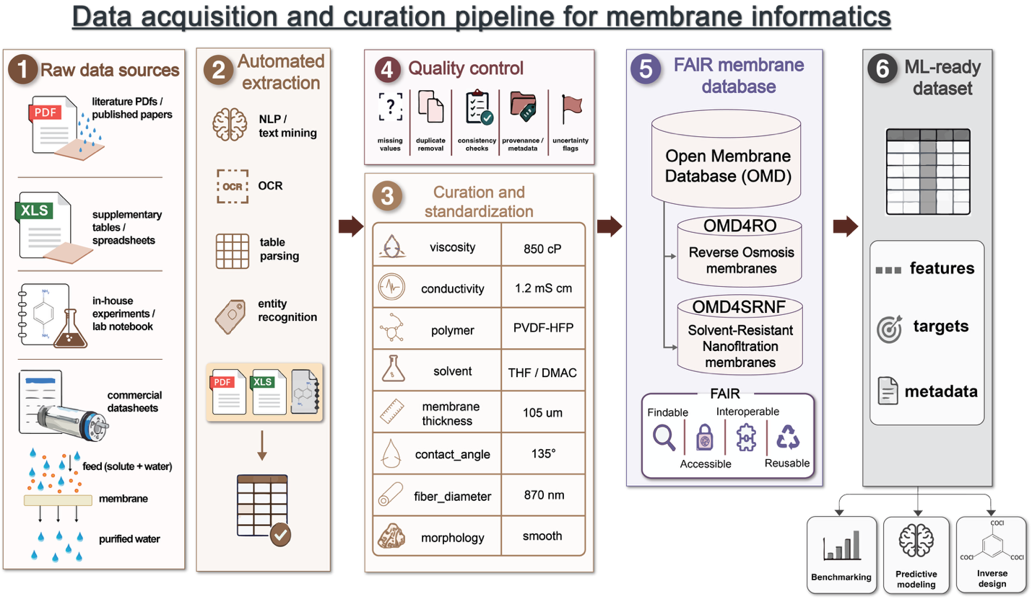
Figure 10. Schematic representation of the automated data curation pipeline in membrane informatics. Unstructured data, historically locked within PDF manuscripts and supplementary tables, is extracted using Natural Language Processing (NLP) and text-mining algorithms. This raw information is subsequently standardized and compiled into centralized, FAIR-compliant repositories, such as the Open Membrane Database (OMD), to train predictive machine learning frameworks.

Morphological informatics
In contrast to tabular descriptors that capture membrane composition, imaging and structural data provide rich morphological information that can be quantitatively analyzed using computer vision and deep learning. These approaches enable extraction of descriptors such as pore size distribution, surface roughness, selective-layer thickness, pore connectivity, tortuosity, and defect characteristics [40,118,119]. Incorporating such features enhances model interpretability and strengthens mechanistic links between membrane morphology and performance.
To make these data suitable for machine learning, morphological information is typically converted into structured representations using both physics-informed descriptors and data-driven feature extraction. Classical image analysis pipelines rely on segmentation or binarization of SEM [40,118], AFM [118], or FIB-SEM images [120,121], followed by quantification of geometric and topological features[122,123], including pore size, porosity, surface roughness, thickness, and connectivity metrics derived from skeletonization or graph-based representations (e.g. node degree, path length, tortuosity). For three-dimensional datasets, voxel-based analysis [124–126]further enables estimation of volumetric porosity, interconnectivity, constrictivity, and tortuosity. Complementary texture descriptors, such as gray-level co-occurrence matrix (GLCM) features and fractal dimensions, capture spatial heterogeneity beyond simple geometric measures[122,127].
Deep learning approaches increasingly enable automated feature extraction from raw images. Convolutional neural networks (CNNs) [123] learn latent morphological embeddings without explicit feature design, while pretrained architectures (e.g., ResNet, VGG)[128] provide transferable representations for small datasets. Autoencoders and variational autoencoders (VAEs) [129] further compress high-dimensional image data into low-dimensional latent spaces suitable for surrogate modeling and inverse design. In segmentation-based pore-network extraction, watershed-segmented pore regions can be organized into graphs in which pores form nodes and connecting throats form edges; these graph representations can subsequently serve as inputs for GNN-based learning of structure–transport relationships[130].
Different microscopy modalities provide complementary morphological information that can be integrated within these frameworks. Scanning Electron Microscopy (SEM) [122]provides high-resolution visualization of surface porosity and cross-sectional architecture, which are closely associated with hydraulic resistance and separation performance. Recent frameworks such as SEMPro [130] integrate deep learning with explainable AI (xAI) to uncover structure–property relationships from SEM images, identifying the most influential morphological features governing predicted mechanical properties. Atomic force microscopy (AFM) complements SEM by providing nanoscale topographical and surface potential information[131–133]. Machine learning models trained on AFM-derived features have been used to classify membrane pore sizes and correlate them with theoretical Stokes radii[134], offering an alternative pathway for linking nanoscale morphology to transport behavior. Focused ion beam scanning electron microscopy (FIB-SEM)[121,126] further extends this capability by enabling three-dimensional reconstruction of internal membrane structure, including pore connectivity and tortuosity, thereby providing more transport-relevant features for predictive modeling and inverse design.
Despite these advances, high-quality membrane image data are often much more difficult to obtain than tabular data, and they tend to be highly system-specific; together, these factors make the scarcity of high-quality annotated datasets even more severe[135,136]. Data augmentation and synthetic labeling strategies have therefore been explored to expand training sets and improve generalization across imaging conditions and platforms[137–139]. For example, SEM images of membrane cross-sections can be augmented through geometric transformations (e.g., rotation, flipping, random cropping) and intensity variations (e.g., contrast adjustment, Gaussian noise) to simulate differences in imaging conditions [139]. More advanced approaches include physics-guided augmentation, such as scaling pore sizes or introducing synthetic defects to mimic fabrication variability, as well as generative models (e.g., GANs or diffusion models) that produce realistic microstructure images for training[140,141]. These strategies have been shown to improve model robustness and reduce overfitting, particularly in small-data regimes typical of membrane studies.
To extend beyond static morphological characterization, video-based data introduces a temporal dimension that captures dynamic processes such as membrane formation, transport, and degradation, which cannot be resolved from single images. Although still relatively underexplored, liquid-phase transmission electron microscopy has been used to generate real-space video data for observing nanoscale assembly and reaction dynamics [142]. However, low signal-to-noise ratios and fluctuating backgrounds remain major challenges, motivating the use of deep learning methods such as U-Net for robust segmentation and tracking.

Physical Simulation
When experimental data are critically scarce, researchers increasingly turn to physics-based simulations to generate physically consistent training data for machine learning. Across scales, from continuum to electronic, different simulation approaches capture complementary aspects of membrane behavior. Computational Fluid Dynamics (CFD) simulation data evaluating heat and mass transfer in membranes [143–146] serves as a rich source for predictive models. For instance, a dataset of 4,500 images generated from CFD algorithms was used to train CNN models for permeability prediction, utilizing pressure and velocity maps to learn the underlying physics of fluid flow through complex nanopores [147]. At the atomistic level, Molecular Dynamics (MD) simulations generate detailed trajectories of atomic movements within membrane pores, with community-contributed simulations stored in repositories like MeTrEx [148,149]. At the electronic scale, Density Functional Theory (DFT) provides data on band gaps, adsorption energies, and reaction pathways [150–152]. These simulation outputs enable machine learning models to detect non-linear relationships between atomic configurations and catalytic performance, enabling the rapid virtual screening of thousands of potential membrane materials before any physical synthesis occurs.
A key challenge in leveraging simulation data is featurization, as raw fields, trajectories, and quantum outputs are typically too high-dimensional for direct use in machine learning models. These data are therefore transformed into representations that preserve relevant physics while enabling efficient learning. Common approaches include: (i) physics-based descriptors such as flux, permeability, diffusion coefficients, and adsorption energies; (ii) structured representations such as images, tensors, and graph-based encodings of local environments; and (iii) learned latent representations obtained from models such as autoencoders. This hierarchy of representations allows models to balance interpretability and expressive power.
Machine learning models trained on simulation-derived features can capture complex structure–property relationships and enable rapid virtual screening of candidate materials prior to experimental synthesis. More importantly, simulations provide a physics-informed representation space that improves model interpretability and enhances extrapolation beyond experimentally observed regimes, making them a critical component of data-driven membrane design.
  - Multimodal Data
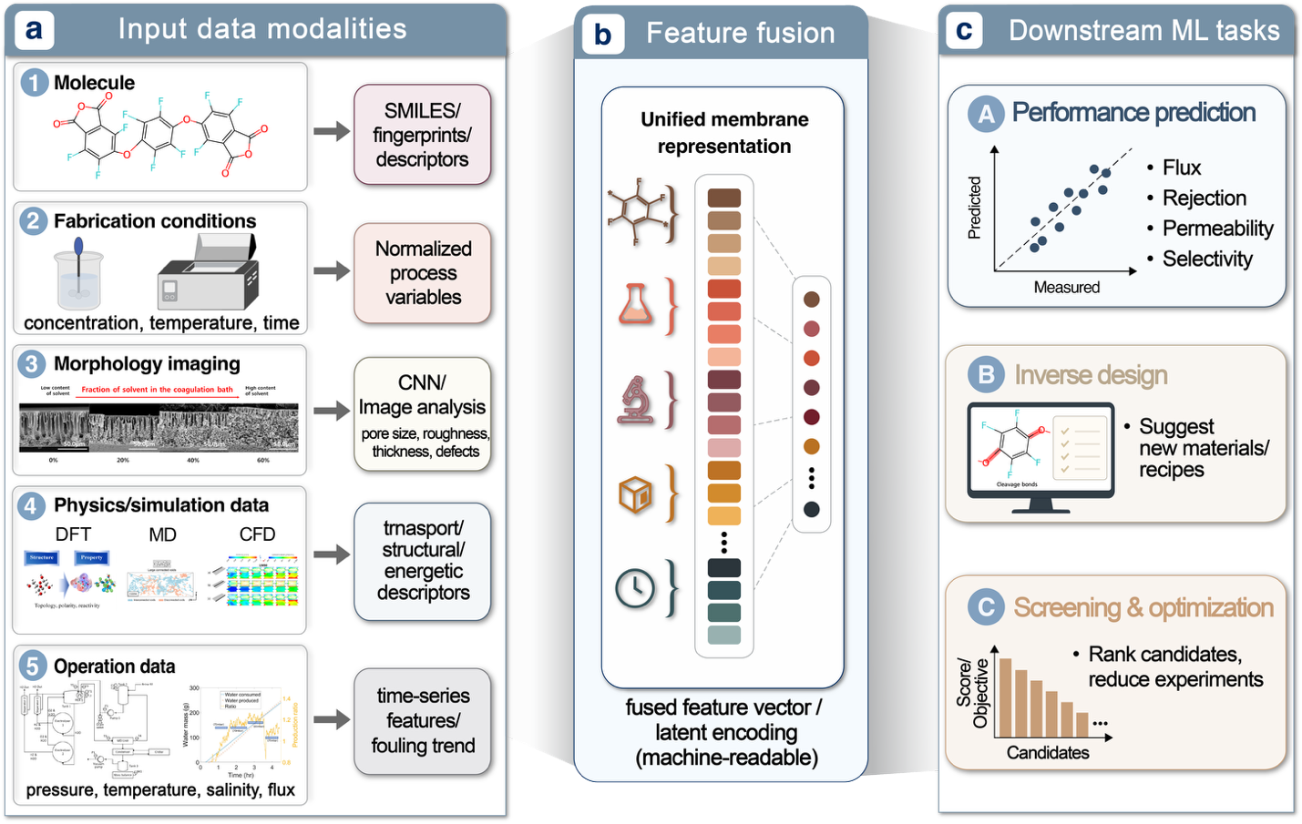
Figure 11. Multi-modal featurization and data representation pipeline for membrane informatics. The schematic illustrates the translation of heterogeneous experimental data into unified, machine-readable formats. (a) Chemical structures are converted into SMILES strings and topological fingerprints to capture molecular-level information. (b) Tabular data, encompassing fabrication parameters and synthesis recipes, is structured into standardized numerical vectors. (c) Morphological data from SEM or AFM imaging is processed via deep learning architectures to extract high-level structural descriptors. These distinct modalities are fused to provide a holistic, multi-dimensional representation of the membrane, enabling more accurate performance prediction and inverse design.
To enable more accurate prediction and inverse design, multimodal strategies integrate tabular fabrication parameters, physics-based labels, and SEM images within a unified modeling framework [6,118,119,153], a technique proven effective in both medical imaging and materials science [141,154]. In practice, effective multimodal learning depends on how each data type is featurized: image modalities can be encoded as latent embeddings, tabular variables as structured numerical features, and polymer or solvent identities as descriptor-based representations before fusion (Fig. 11).
To enable accurate prediction and inverse design, multimodal learning integrates fabrication parameters, physics-based labels, and SEM images by encoding each modality into a suitable representation before fusion. In membrane research, this approach is emerging through datasets and models that link processing conditions, microstructure, and performance, such as the Hereon Isoporous Polymer Membrane Production (HIPMP) dataset and recent frameworks for predicting permeate flux in dynamic membranes using adsorbent properties [155]. Similar work on electrospun nanofibers demonstrates that combining tabular processing variables with SEM-derived structural features can improve property prediction, support cross-modal retrieval, and enable structure generation and inverse design, even when some modalities are unavailable[141].
Related hybrid frameworks have also coupled GANs with CNN surrogates to design membranes with prescribed strength [156]. In parallel, techniques such as Label as a Feature (LaaF) can help mitigate modality imbalance and maintain predictive robustness when one modality is missing [157–160]. Overall, this field is still emerging, and only a limited number of membrane-focused multimodal studies have been reported so far.
In summary, this section has outlined the key data modalities and acquisition pathways available to membrane researchers, together with the featurization and multi‑scale representation strategies that convert these raw observations into ML‑ready inputs for membrane development. Together, these choices of data source and representation define the raw inputs and standardized infrastructure that underpin downstream tasks such as property prediction, process optimization, and inverse design.

ML Workflows: Orchestrating the Membrane Design Assembly Line

Figure X. Closed-loop machine-learning workflow for membrane inverse design, spanning objective definition, data schema development, multi-scale featurization, preprocessing, surrogate and digital twin training, explainable AI, virtual screening, inverse optimization, and empirical validation.
Building on the computational machinery introduced in Section 2 and the experimentalist’s data toolbox established in Section 3, the following section shows how to orchestrate these elements into a coherent membrane design workflow derived from common Machine Learning literatures in membrane development [54,77,107,113,159,161–163]. A companion tutorial notebook is available at [_____(link)] and provides complete code, sample datasets, and step-by-step guidance for surrogate modelling, Bayesian optimization, and inverse design. Together, these resources support an end-to-end pipeline covering data ingestion, preprocessing, model development, evaluation, SHAP-based interpretation, and iterative refinement, enabling literature-derived membrane datasets to be transformed into reproducible machine learning–assisted optimization workflows within a systematic 9-step closed-loop lifecycle.
Step 1: Set Objectives and Constraints
The workflow begins with the establishment of objectives and constraints aligned with the target application. For membrane material discovery and fabrication, these objectives may include high water flux, strong salt rejection, or specific gas selectivity, whereas in operational settings the emphasis may shift toward flux stability, fouling mitigation, or reduced energy consumption. In parallel, manufacturing and operational boundaries, such as solvent restrictions, thickness limits, or allowable pressure ranges, are encoded as explicit constraints to ensure that the resulting design space remains physically realizable and industrially relevant.
Step 2: Design Data Schema and Data Ingestion
A critical early step is the design of a rigorous data schema and acquisition strategy. Historical literature data, laboratory notebooks, simulation outputs, and internal experimental records are consolidated into structured formats in which each entry corresponds to a membrane batch, fabrication recipe, or operating condition. Standardizing the data schema helps reduce architectural bias, improves reproducibility, and ensures that chemical identities, solvent ratios, casting conditions, pore characteristics, and testing protocols are consistently represented. This structured foundation is essential for building reliable models from heterogeneous membrane datasets.
Step 3: Data Inspection:
After data collection, the dataset is imported into the machine learning environment for subsequent modelling and inverse design. Prior to model development, an initial data quality assessment is essential to identify missing values, duplicated entries, and outliers, as these can distort statistical analysis and degrade model performance. Missing data may reduce the effective sample size, introduce bias, or disrupt preprocessing and learning algorithms, while duplicated entries can skew distributions and lead to overly optimistic model evaluation.
In membrane research datasets, such issues can obscure true structure–property relationships; for instance, duplicated experiments may exaggerate the prevalence or performance of specific fabrication conditions, whereas incomplete records may conceal critical trends. Early identification of these flaws enables appropriate corrective actions, such as imputation or removal, ensuring that subsequent feature engineering and model training are based on reliable and representative data.
Step 4: Feature Engineering and Exploratory Data Analysis (EDA)
Following data quality assessment, feature engineering and exploratory data analysis (EDA) are performed in an iterative manner to construct and refine a representation that captures chemistry–process–performance relationships. Feature engineering begins by enriching the raw fabrication dataset through the integration of auxiliary descriptors (e.g., cation and anion properties such as Stokes radius and charge) and the selection of physically meaningful fabrication and testing variables.
This process can be readily extended to include molecular, polymer, solvent, or mixture-level descriptors derived from databases or literature. Beyond tabular descriptors, this step can also incorporate multimodal data to provide a more comprehensive representation of membrane systems. For example, microscopy images (e.g., SEM or AFM) can be encoded using convolutional neural networks to capture morphological features, while spectral data (e.g., FTIR or Raman) can be transformed into quantitative descriptors reflecting chemical structure. These additional modalities can be integrated with conventional tabular features either through feature concatenation or more advanced representation learning approaches, enabling the model to leverage complementary structural, chemical, and process information.
Concurrently, EDA is used to examine the distributions and relationships within the evolving feature space, including key variables and target properties such as permeability and rejection. Visualization of feature distributions and correlation structures provides insight into data variability, redundancy, and potential structure–property relationships. These observations inform subsequent refinement of the feature set, such as removing near-constant variables, reducing highly correlated descriptors, or incorporating additional relevant features.
Importantly, feature engineering and EDA are not strictly sequential but form a feedback loop: insights gained from EDA guide feature selection and transformation, while updated features prompt further exploration. This iterative process is particularly critical in membrane research, where limited and heterogeneous datasets require careful balancing between physical interpretability and statistical robustness. The outcome is a refined feature matrix that supports reliable model training and interpretation in subsequent steps.
Step 5: Model pipeline selection, fine-tuning and evaluation
Before model training, the dataset is first split into training and test sets using a fixed random seed, and cross-validation is applied within the training set to support model selection and hyperparameter tuning (ref). This gurranteed the AI is trained on historical membrane batches and tested on entirely unseen, newly fabricated sequences and the model learns genuine underlying physics rather than memorizing spreadsheet layouts

A complete modelling pipeline is then constructed by combining data preprocessing, model training, and hyperparameter optimization in a unified framework. The preprocessing stage may include imputation of missing values, standardization or normalization of numerical features, and encoding of categorical variables when needed. The processed training data are used to fit candidate predictive surrogate models that map multidimensional inputs to output properties. Depending on the data modality and prediction task, these models may include ensemble methods such as Random Forests or XGBoost for tabular material and fabrication data, deep neural networks for image-based microscopy inputs, or recurrent architectures for time-dependent processes (ref). Grid search or randomized search can then be applied to tune hyperparameters in a reproducible way.
This pipeline-based design provides a systematic and extensible way to compare different algorithms while reducing the risk of data leakage. Model performance is summarized using standard regression metrics such as $R^{2}$, RMSE, and MAE on the held-out test set. A parity plot is used to complement these metrics by comparing predicted and observed values for each test sample; points near the diagonal indicate good agreement, whereas systematic deviations or wide scatter reveal bias or weak predictive regions.
In membrane datasets with limited sample size, this evaluation step is especially important because predictive performance should be interpreted in the context of feature coverage, experimental variability, and overall data quality. The fitted model can then be carried forward to the next step, where SHAP analysis is used to interpret the contribution of individual descriptors and their interactions.
Step 6: Interpret Process Drivers via Explainable AI (xAI)
Once a surrogate model has been established, explainable AI methods are used to identify the dominant process drivers and to ensure that inverse design does not yield mathematically optimal but physically implausible solutions. Among the most widely used xAI approaches, SHAP is particularly useful because it quantifies the contribution of each feature to individual predictions while also revealing global patterns across the dataset.
In membrane modelling, this interpretability step links the statistical model back to physically meaningful mechanisms. It can show whether predictions are driven by specific chemical functional groups, coagulation time, feed temperature fluctuations, or other structural, chemical, and operational variables. SHAP summary plots highlight the most influential descriptors, while dependence and local explanation plots clarify how feature values affect permeability and rejection in specific cases. A model was considered acceptable only when the dominant features identified by SHAP were physically meaningful and consistent with known membrane structure–process–property relationships.
- By comparing these explanations with physical intuition, the model can be checked for consistency and potential artefacts. This makes the framework not only predictive but also informative, supporting experimental verification and guiding the search for plausible membrane designs. This criterion helps avoid over-reliance on statistically accurate but physically implausible models, which is particularly important for inverse design applications.
Step 7: High-Throughput Virtual Screening and Inverse Design
Once validated, the surrogate model can be used in two complementary ways: high-throughput virtual screening and inverse design. In high-throughput screening, the model acts as a rapid computational filter that evaluates large numbers of candidate formulations, fabrication recipes, or operating conditions in silico. This enables efficient prioritization of promising candidates before laboratory validation and also makes it possible to probe extreme or high-risk scenarios that would be costly or impractical to test experimentally.
In inverse design, the surrogate is used in reverse: given a desired performance target, optimization algorithms search for the input conditions most likely to achieve it. For membrane development, this may involve Bayesian optimization to identify promising recipes with relatively few experiments, or generative models to propose new molecular architectures and formulation candidates. The same framework can also be extended to process control, where model-guided setpoint selection supports adaptive operation under changing conditions (ref).
Together, these two uses transform the surrogate model from a predictive tool into a design engine. Rather than only describing existing data, the model can screen large design spaces, rank viable candidates, and guide the search for new membranes and operating conditions with improved performance.
Step 8: Empirical Validation
The proposed solutions should then be validated experimentally. Candidate membranes, formulations, or operational strategies generated by the inverse design framework are synthesized, tested, and compared with the predicted outcomes using standard characterization and performance measurements. Techniques such as SEM, FTIR, permeability testing, and pilot-scale operation provide the evidence needed to assess whether the proposed design is reproducible, robust, and practically meaningful.
This validation step is essential because surrogate-driven predictions remain hypotheses until confirmed experimentally. Beyond verifying agreement between predicted and observed performance, the results can also indicate whether the model generalizes beyond the original dataset and whether the optimized candidates retain their advantages under realistic conditions. The validated data then become new input for the next stage of continuous refinement and model updating, rather than marking the end of the workflow. In this way, empirical validation closes the experimental loop while preparing the framework for iterative improvement in the final CICD step.
Step 9: Continuous Refinement and Model Updating
The inverse-design solutions predicted by the machine learning model should be treated as optimized candidates for the specified target, but their experimentally measured performance may still deviate from the predicted values(ref). This discrepancy can arise when the experimental setting differs from the distribution represented in the training data, or when unmodeled effects, fabrication variability, measurement noise, and incomplete descriptors limit model fidelity. Such gaps make a closed-loop continuous refinement framework necessary.
To close the loop, real-world performance metrics obtained during validation are fed back into the database. An active learning cycle can then prioritize regions where the model is uncertain or where experimental outcomes deviate from prediction, allowing retraining with high-value data points that improve accuracy and robustness in underexplored regions of the design space. In this way, the workflow gradually becomes more reliable with each iteration, rather than remaining fixed after the first round of inverse design.
As the framework matures, the data-driven surrogate can also be coupled with physics-informed constraints and hybrid control logic. Mechanistic relationships such as Darcy’s law, thermodynamic limits, and mass-transfer equations can be embedded directly into the design and optimization process to keep proposed solutions physically plausible and to reduce unsafe or unrealistic operating conditions (ref). This hybrid layer acts as a safeguard against infeasible proposals and helps ensure that the model remains aligned with known membrane behavior.
Transfer learning can be introduced as a complementary strategy when the workflow is extended to a new membrane family or a different experimental domain. In such cases, knowledge learned from a broader source dataset can be transferred and fine-tuned on a smaller target dataset, helping the model adapt more efficiently under limited-data conditions. Together, active learning and physics-informed constraints form the core of the closed-loop refinement process, while transfer learning provides an additional route for adaptation when the design problem shifts to a new domain.

Case Studies: Success Stories in ML-Driven Fabrication
Application of ML in membrane science has evolved from passive performance prediction to active inverse design and process control. By analyzing the complex non-linear relationships between fabrication variables (e.g., monomer structure, solvent properties, casting temperature) and operational outcomes (e.g., flux, selectivity, fouling rate), ML is now enabling the rational design of membranes. This section reviews widely cited and emerging case studies categorized by three distinct phases: (1) Material discovery and inverse design of TFC membranes (2) Membrane fabrication, and (3) Process Optimization & Fouling Control. For summary of these case studies, refer to Table 3

Material Discovery and Inverse Design of TFC Membranes
Polyamide thin-film composite (TFC) membranes remain the gold standard for desalination, yet their fabrication via interfacial polymerization (IP) involves a vast combinatorial space of monomers and reaction conditions. In 2022, Gao et al. utilized BO to navigate the infinite candidate space. Unlike traditional Edisonian approaches, they trained models on monomer structures (represented by Morgan fingerprints) to inversely predict optimal fabrication recipes. The model successfully identified novel combinations of unexplored monomers and synthesis conditions, leading to membranes that experimentally exceeded the permeability-selectivity upper bound of commercial counterparts [164]. Building on this, in 2025, Ma et al. introduced a fragment-based ML approach. By decomposing monomers into chemical fragments, their CatBoost model could essentially "assemble" ideal monomer structures for specific water purification targets. This automated the discovery of novel amine monomers, significantly accelerating the R&D cycle for high-performance NF membranes [77]. Similarly, in 2020, Barnett et al. demonstrated a complete design-to-device workflow. They screened 11,000 hypothetical homopolymers using a topological path-based hash. The model identified two specific polymer structures predicted to surpass the Robeson upper bound for CO₂/CH₄ separation. Crucially, the team synthesized these novel polymers in the lab, confirming the ML predictions and proving that ML can guide the synthesis of high-performance materials from scratch [46].

Precision in membrane fabrication
Beyond material selection, the specific conditions of fabrication—such as solvent choice and electrospinning parameters—dictate membrane morphology. Understanding these black box synthesis-structure relationships is a key strength of ML.
Ignacz et al. have applied XAI to decipher the role of solvents in Organic Solvent Nanofiltration (OSN) membranes in 2023. By analyzing 407 solutes across 11 solvent systems, they used SHAP values to quantify how solvent parameters, such as Hildebrand solubility and electrotopological state, influenced rejection. The study provided mechanistic insights into solvent-induced swelling, guiding the selection of solvent systems that maintain pore integrity during fabrication [81]. Similarly in 2025, for solution casting, Carrillo-Sánchez et al. integrated ML with RSM to optimize the casting temperature and solvent composition for Pebax® 1657 membranes, identifying non-obvious fabrication windows that maximized CO₂ selectivity [165].
For nanofibrous membranes, Pervez et al. addressed the chaotic instability of electrospinning jets. They developed a hybrid ML model (RSM + Locally Weighted Kernel Partial Least Squares) to predict nanofiber diameter based on voltage, flow rate, and polymer concentration. This allowed for the precise fabrication of nanofibers with targeted diameters for specific filtration applications, reducing the trial-and-error typically required to stabilize the electrospinning process [166].
Fabrication goals in energy sectors (fuel cells, lithium extraction) differ from that of water treatment or gas separation, often requiring the optimization of conductive channels or ion-specific sieving. Zhang et al. employed a Fully Connected Neural Network (FCNN) to screen 180,000 anion exchange membrane (AEM) structures for fuel cells in 2024. The model revealed that the inductive effect of benzene rings on anilinium cations was critical for forming continuous ion transport channels. This insight guided the synthesis of highly conductive membranes that outperformed commercial benchmarks [75]. Following this study, in 2025, Sun et al. applied ML to fine-tune the fabrication of NF membranes for Li⁺/Mg²⁺ separation. The study correlated fabrication parameters (e.g., reaction time, monomer concentration) with the steric and electrostatic exclusion mechanisms required to separate mono- from divalent ions. The ML analysis highlighted that precise control of the polyamide cross-linking density was the deciding factor for high Lithium selectivity [49].

Process Optimization and Fouling Mitigation
The utility of ML extends beyond fabrication into the operational phase, where it is used to optimize process parameters and mitigate fouling—a feedback loop that can inform future fabrication designs. ANNs and SVMs, are deployed to predict fouling rates in Reverse Osmosis (RO) and Forward Osmosis (FO) systems. By training on operational data (feed pH, temperature, pressure), these models can predict flux decline with high accuracy R² > 0.95), allowing operators to adjust cross-flow velocities or initiate cleaning cycles proactively [105].
Specific to fouling mechanisms, in 2023, Dansawad et al. highlighted studies using DNN to model the growth of cake layers and pore blocking (ref). These models not only predict membrane lifespan but also suggest optimal backwashing intervals and cleaning protocols. By integrating these process models with fabrication data, researchers are beginning to close the loop—designing membranes with surface properties (e.g., hydrophilicity, roughness) specifically tailored to minimize the ML-predicted fouling propensities for specific wastewater feeds [4].
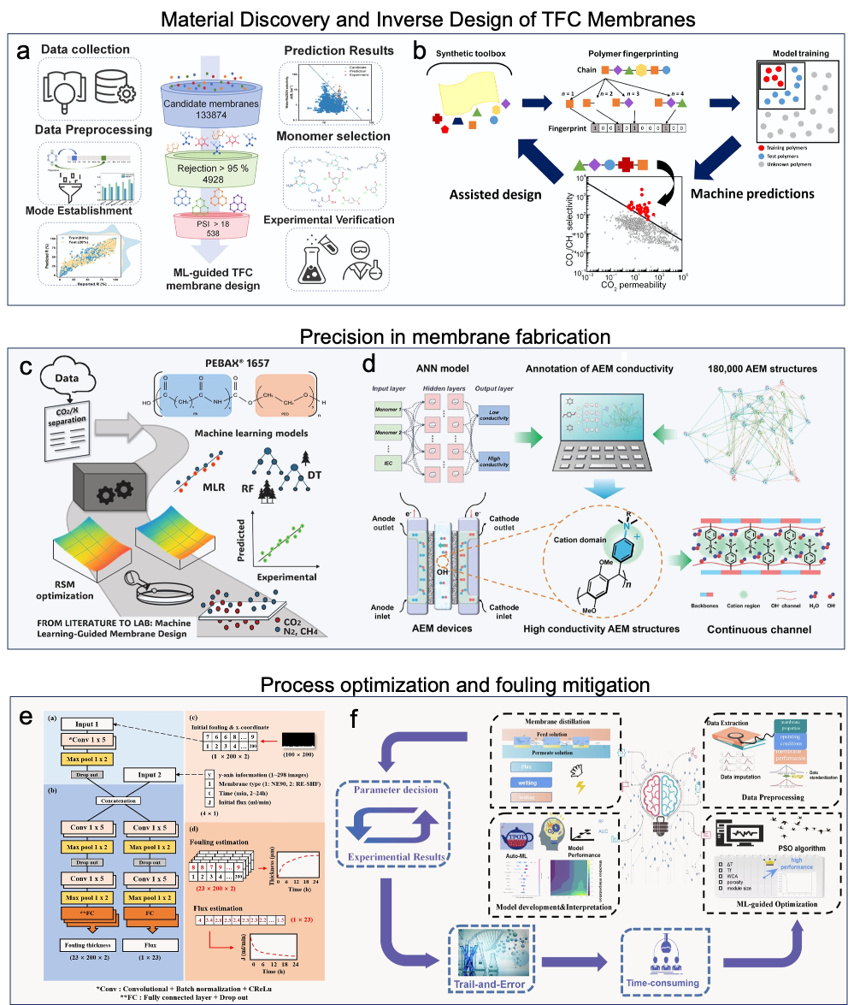

Figure 12. a. Fragment-based ML identified top-performing thin-film composite polyamide membranes from 133864 candidates [Accelerating inverse design of thin-film composite polyamide membranes for water purification via fragment-based machine learning]; b. ML model predicted gas separation performance 11,000 homopolymer membranes[Designing exceptional gas-separation polymer membranes using machine learning]; c. ML optimized membrane preparation conditions for the separation of CO2/N2 and CO2/CH4 mixtures [Membrane preparation assisted by integration of machine learning and response surface methodology for CO2 separation]; d. Neural network model was developed to screen 180,000 anion exchange membrane (AEM) structures for fuel cells [Machine Learning-Aided Design of Highly Conductive Anion Exchange Membranes for Fuel Cells and Water Electrolyzers]; e. Membrane fouling based on fouling layer thickness were evaluated using deep learning [Deep neural networks for modeling fouling growth and flux decline during NF/RO membrane filtration]; f. ML was used to predict and optimize trade-offs between factors affecting membrane distillation to enhance system performance [Machine learning-guided underlying decisive factors of high-performance membrane distillation system: Membrane properties, operation conditions and solution composition].

Challenges, Limitations and Future Direction
While machine learning has already accelerated membrane research, its impact is still constrained by three closely linked barriers: limited data quality, weak model generalizability, and incomplete integration with experiment and scale-up. Progress now depends less on selecting a “better” algorithm and more on improving data infrastructure and enabling closed-loop, process-aware learning.
  - Data quality, completeness, and benchmarking
Membrane machine learning is constrained by both data scarcity and poor data quality[167,168]. Existing datasets, typically aggregated from literature and individual laboratory records, are characterized by inconsistent curation, incomplete metadata, and, most critically, missing fabrication and characterization details[169,170]. Because membrane performance is inherently path-dependent [171–173], this is not a minor omission but a structural limitation: the effective sample density in the process–structure–performance space remains extremely low [171].
This limitation is further exacerbated by reporting bias toward successful and optimized outcomes, while failed experiments, intermediate trials, and full process histories are rarely disclosed [174]. As a result, models trained on such incomplete datasets often learn spurious correlations, linking material identity to performance while overlooking latent process variables that govern morphology and transport. Consequently, models that appear accurate frequently fail under modest changes in fabrication conditions.
Benchmarking practices further obscure real progress. Metrics such as $R^{2}$or MAE often difficult to compare directly across studies due to inconsistent data splits, target definitions, preprocessing workflows and data leakage arising from structurally or procedurally similar samples appearing in both training and test sets[175,176]. Reported performance therefore often reflects evaluation design rather than genuine predictive capability.
Addressing these challenges requires a shift toward standardized, machine-readable data schemas with explicit encoding of process variables, minimum reporting standards that include negative results, and rigorous benchmarking protocols based on fixed splits and truly external validation. Community initiatives such as the Open Membrane Database [171] are promising, but their long-term value will depend on capturing process-level detail and enabling reproducible, process-aware evaluation.
Progress will ultimately depend on transitioning from passive data aggregation to closed-loop data generation. Active learning, Bayesian optimization [44], and self-driving laboratory systems [11,102] can iteratively select the most informative experiments and update models in real time. When integrated with automated synthesis, characterization, and standardized data pipelines, these platforms can directly produce consistent, machine-readable datasets with fully recorded process variables and experimental histories. This not only reduces human-induced variability but also systematically improves coverage of underexplored regions in the process–structure–performance space, addressing both data sparsity and bias at their source [168].

Generalizability, uncertainty, and interpretability
A second major limitation is robust generalization outside the training domain: many models reporting strong performance under random train–test splits nonetheless overstate real-world predictive capability [177], because test points remain statistically similar to training data. In membrane science this problem is amplified by multi-regime heterogeneity, for example distinct material classes (different layered structures in interfacial polymerized membranes and mixed-matrix membranes), fabrication routes (interfacial polymerization, phase inversion, electrospinning)[178–180], separation physics (solution–diffusion, pore flow, membrane distillation)[181,182], addition of additives and functional materials (surfactants and nanoparticles)[178,183,184] and characterization methods (conductivity v.s. ICP for salt rejection)[184,185] which produces distribution shifts that legacy datasets rarely capture. Simple test-set performance therefore does not guarantee reliability for novel chemistries, underrepresented additives, or unexplored processing windows [186]; practitioners should adopt domain-aware validation such as grouped splits by polymer family, fabrication method, or lab provenance [176,187,188].
Interpretability tools alone do not resolve this weakness[189]: post-hoc explainers (SHAP, LIME) [190]can highlight correlated features but often reflect dataset biases rather than causal transport mechanisms, particularly when fabrication variables, solvents, and testing conditions are entangled. Thus, feature importance must be treated cautiously and, where possible, complemented by causal or mechanistic checks (e.g., targeted experiments, causal discovery, or physics-based constraints) to avoid spurious conclusions.
Uncertainty-aware modeling adds a useful safety check. Ensemble [191] and Bayesian methods [192] can give a sense of how much the model’s prediction depends on the training data, while conformal prediction can provide prediction ranges with reliable coverage [188] even when the model is not perfect [193,194]. These uncertainty estimates can help flag inputs that are far from the training examples and produce more cautious predictions when the model is less confident. It is also important to separate uncertainty caused by limited data from uncertainty that is unavoidable in the measurements themselves, and to report simple calibration checks such as reliability plots or error-based confidence summaries. Taken together, domain-aware data splitting [195], explanations checked against physical intuition or causal reasoning, and well-calibrated uncertainty estimates make membrane ML models more trustworthy than relying on any one of these ideas alone.

Scale-up, deployment, and autonomous discovery
The third challenge is the gap between predictive modeling and real experimental or industrial deployment. An inverse designed membrane with perfect predicted performance may not work well in experiment [170]; similarly, a membrane that performs well in a laboratory experiment may behave differently at module scale [196,197] because of hydrodynamics, concentration polarization, fouling, pressure losses, and long-term aging. This means that even strong material-level predictions do not automatically translate into process-level performance. For membrane ML to become practically useful, models must increasingly account for operating conditions, module architecture, and scale-dependent failure modes [198]
Transfer learning offers a promising route to this goal by allowing models to learn generalizable structure–property relations from abundant laboratory data and then adapt them to sparse module-scale data. Instead of retraining from scratch, a pretrained model can be fine-tuned on pilot or industrial observations, preserving transferable knowledge [168,199,200] while correcting for domain shift caused by scale-up, flow regime changes, and operational stress. This substantially reduces the data burden associated with realistic deployment. Similar transfer-learning logic has been used in other fields, where models trained on abundant source data are adapted to sparse target domains or new configurations, including materials property prediction [201] and configurable-system performance modeling [202].
Importantly, transfer learning can also be combined with physics-informed representations, such as transport descriptors, hydrodynamic features, or simulation-derived variables, to improve robustness and interpretability [203]. In this hybrid setting, the model learns not only which membrane features are intrinsically favorable, but also how those features translate under process-relevant conditions. As a result, transfer learning provides a practical framework for bridging the persistent mismatch between laboratory prediction and industrial performance.
The emergence of self-driving laboratories (SDLs) and autonomous experimental systems offers a complementary pathway to close the prediction–deployment gap [204–206]. These platforms integrate robotics, AI-driven decision-making, and high-throughput experimentation into closed-loop workflows that can synthesize, characterize, and test materials with minimal human intervention. For membranes, autonomous discovery can be deployed at three levels that map directly onto the scale-up challenge: (i) material-level automation, where robotic platforms automate membrane fabrication (e.g., interfacial polymerization, electrospinning, phase inversion) with precise control over synthesis parameters to generate consistent structure–property datasets ; (ii) module-level testing, where integrated fluidic robotics and automated test rigs evaluate membranes under realistic hydrodynamic conditions, systematically capturing scale-dependent phenomena such as concentration polarization, fouling dynamics, and pressure drop; and (iii) closed-loop optimization, where Bayesian active learning and multi-agent AI frameworks [204] decide the next synthesis or testing condition based on all available data, focusing experimental effort on high-uncertainty or high-reward regions rather than exhaustive searches . When combined with transfer learning, an SDL can first generate abundant laboratory-scale data to pretrain models on structure–property relations, then collect sparse but targeted module-scale data for fine-tuning on the same hardware, reducing domain shift and improving data efficiency [207]. By embedding scale-aware experimentation into the discovery loop itself, robotics-enabled SDLs provide a systematic mechanism to generate the multi-scale, process-relevant data that transfer-learning models need to generalize from lab to industry, helping ensure that inverse-designed membranes are not only optimal in silico but also robust and deployable in real-world systems.

Conclusions and Outlook
The preceding sections have summarized the applications of machine learning across the entire membrane lifecycle—from material discovery and fabrication to dynamic process optimization. As is evident, machine learning has already helped researchers address a multitude of complex challenges. With continued advances in AI architectures, there is strong reason to expect that even more intricate bottlenecks in membrane science will be tackled in the coming years. In the foreseeable near term, the relationship between researchers and the broader spectrum of AI tools will be highly synergistic and mutually reinforcing. However, given that a massive amount of routine computational and experimental work will inevitably be overtaken by AI, it is not too early to consider how researchers must position themselves in the automated era.
To remain indispensable, it is essential to recognize a key limitation of current AI: its foundational mechanism is inductive inference. Its novelty is primarily statistical rather than agentic; it generates new outputs in a distributional sense rather than arising from subjective intention or lived experience. Accordingly, machine-learning systems are typically unreliable when confronted with genuinely novel mechanisms or out-of-distribution shifts. Recent meta-scientific studies suggest that after adopting AI-augmented tools, scientists’ efforts disproportionately shift toward the most data-rich domains, which paradoxically leads to a contraction in the overall breadth of collective scientific coverage [208–210]. In membrane science, this manifests as a "gravitational pull" toward heavily studied legacy materials (e.g., conventional polyimides or polysulfones) at the expense of exploring data-scarce, yet potentially revolutionary, novel architectures. This paradox serves as a critical reminder that human intelligence remains most decisive exactly where no established roadmap exists. Humans possess the capacity for paradigm-shifting creativity: we do not merely optimize answers but reformulate the questions themselves and redefine the fundamental evaluation criteria. These are the cognitive processes that underpin true scientific revolutions. By contrast, machine learning generally struggles to achieve out-of-distribution breakthroughs that require rewriting conceptual frameworks. Therefore, looking ahead, a researcher’s ability to "think outside the box" will become increasingly paramount. The primary focus of human scientific work must shift toward bravely exploring new, data-poor domains, rather than merely pursuing the automated optimization of well-established ones [208].
Moreover, no form of AI can meaningfully bear moral or social responsibility for its consequences in a human-centered society. In high-stakes membrane applications—such as potable water desalination, medical hemodialysis, or industrial carbon capture—algorithmic failures carry severe real-world consequences. For this reason, ensuring that AI-enabled outputs are legally compliant, ethically defensible, and practically safe requires rigorous review by individuals with deep domain expertise. In practice, such human-in-the-loop oversight is a central pillar of responsible AI governance, because accountability ultimately remains with human actors and institutions rather than the model itself [41].
This requirement highlights a vital, long-term professional trajectory for researchers beyond the pursuit of paradigm-shifting breakthroughs. While revolutionary innovation remains crucial, an equally vital and socially necessary role is that of the expert reviewer and auditor [211,212]. These positions demand deep disciplinary knowledge, independent critical judgment, and a comprehensive command of both physical theory and laboratory practice. In this future framework, AI-generated "reasoning" serves merely as one highly efficient component within a broader decision-making pipeline. It is the robust scrutiny by human experts that ensures we remain firmly in control, guaranteeing that the ultimate authority—and indeed the responsibility—does not migrate to the machine.

[1] D. Feldman, Polymer History, Des. Monomers Polym. 11 (2008) 1–15. https://doi.org/10.1163/156855508X292383.
[2] Encyclopedia of Membrane Science and Technology, Encyclopedia of Membrane Science and Technology (2013). https://doi.org/10.1002/9781118522318.
[3] P.J. Choi, J. Lee, A. Jang, Interconnection between renewable energy technologies and water treatment processes, Water Res. 261 (2024) 122037. https://doi.org/10.1016/J.WATRES.2024.122037.
[4] R.W.. Baker, Membrane technology and applications, (2024) 539.
[5] P. Dansawad, Y. Li, Y. Li, J. Zhang, S. You, W. Li, S. Yi, Machine learning toward improving the performance of membrane-based wastewater treatment: A review, Advanced Membranes 3 (2023) 100072. https://doi.org/10.1016/J.ADVMEM.2023.100072.
[6] Y. Xu, X. Liu, X. Cao, C. Huang, E. Liu, S. Qian, X. Liu, Y. Wu, F. Dong, C.W. Qiu, J. Qiu, K. Hua, W. Su, J. Wu, H. Xu, Y. Han, C. Fu, Z. Yin, M. Liu, R. Roepman, S. Dietmann, M. Virta, F. Kengara, Z. Zhang, L. Zhang, T. Zhao, J. Dai, J. Yang, L. Lan, M. Luo, Z. Liu, T. An, B. Zhang, X. He, S. Cong, X. Liu, W. Zhang, J.P. Lewis, J.M. Tiedje, Q. Wang, Z. An, F. Wang, L. Zhang, T. Huang, C. Lu, Z. Cai, F. Wang, J. Zhang, Artificial intelligence: A powerful paradigm for scientific research, The Innovation 2 (2021) 100179. https://doi.org/10.1016/J.XINN.2021.100179.
[7] K.T. Butler, D.W. Davies, H. Cartwright, O. Isayev, A. Walsh, Machine learning for molecular and materials science, Nature 559 (2018) 547–555. https://doi.org/10.1038/s41586-018-0337-2.
[8] J. Jumper, R. Evans, A. Pritzel, T. Green, M. Figurnov, O. Ronneberger, K. Tunyasuvunakool, R. Bates, A. Žídek, A. Potapenko, A. Bridgland, C. Meyer, S.A.A. Kohl, A.J. Ballard, A. Cowie, B. Romera-Paredes, S. Nikolov, R. Jain, J. Adler, T. Back, S. Petersen, D. Reiman, E. Clancy, M. Zielinski, M. Steinegger, M. Pacholska, T. Berghammer, S. Bodenstein, D. Silver, O. Vinyals, A.W. Senior, K. Kavukcuoglu, P. Kohli, D. Hassabis, Highly accurate protein structure prediction with AlphaFold, Nature 596 (2021) 583–589. https://doi.org/10.1038/s41586-021-03819-2.
[9] A. Merchant, S. Batzner, S.S. Schoenholz, M. Aykol, G. Cheon, E.D. Cubuk, Scaling deep learning for materials discovery, Nature 2023 624:7990 624 (2023) 80–85. https://doi.org/10.1038/s41586-023-06735-9.
[10] A. Tayyebi, A.S. Alshami, X. Yu, E. Kolodka, Can machine learning methods guide gas separation membranes fabrication?, Journal of Membrane Science Letters 2 (2022) 100033. https://doi.org/10.1016/J.MEMLET.2022.100033.
[11] C. Wang, Fabrication and machine learning of nanocomposite organic solvent nanofiltration membranes, University of Technology Sydney, 2023.
[12] M.J. Talukder, A. Alshami, A. Tayyebi, N. Ismail, X. Yu, A.S. Alshami, Membrane Science Meets Machine Learning: Future and Potential Use in Assisting Membrane Material Design and Fabrication, (2023). https://commons.und.edu/che-fac (accessed January 6, 2026).
[13] J.F. Wang, Y.B. Sun, Q.T. Chen, F.F. Ji, Y.Y. Song, M.Y. Ruan, Y. Wang, OpenPoly: A Polymer Database Empowering Benchmarking and Multi-property Predictions, Chinese Journal of Polymer Science 2025 43:10 43 (2025) 1749–1760. https://doi.org/10.1007/S10118-025-3402-Y.
[14] J. Cai, X. Chu, K. Xu, H. Li, J. Wei, Machine learning for membrane design and discovery, (2020). https://doi.org/10.1039/d0na00388c.
[15] S.A. Siddiqui, A. Mahmood, Q.Z. Sheng, H. Suzuki, W. Ni, S.A. Siddiqui, A. Mahmood, Q.Z. Sheng, H. Suzuki, W. Ni, Towards a Machine Learning Driven Trust Management Heuristic for the Internet of Vehicles, Sensors 2023, Vol. 23, 23 (2023). https://doi.org/10.3390/S23042325.
[16] Z.H. Zhou, Machine Learning, Mach. Learn. (2021) 1–458. https://doi.org/10.1007/978-981-15-1967-3/COVER.
[17] C. Zhu, E.A. Bamidele, X. Shen, G. Zhu, B. Li, Machine Learning Aided Design and Optimization of Thermal Metamaterials, Chem. Rev. 124 (2024) 4258–4331. https://doi.org/10.1021/ACS.CHEMREV.3C00708.
[18] F. Shi, S. Lu, J. Gu, J. Lin, C. Zhao, X. You, X. Lin, Modeling and Evaluation of the Permeate Flux in Forward Osmosis Process with Machine Learning, Ind. Eng. Chem. Res. 61 (2022) 18045–18056. https://doi.org/10.1021/ACS.IECR.2C03064.
[19] M. Nurhayati, K. Jeong, H. Lee, J. Park, B.U. Hong, H.G. Kang, H.K. Shon, S. Lee, Predicting and optimizing forward osmosis membrane operation using machine learning, Desalination 592 (2024) 118154. https://doi.org/10.1016/J.DESAL.2024.118154.
[20] Y. Wang, A. Machado, A. Telea, Y. Wang, A. Machado, A. Telea, Quantitative and Qualitative Comparison of Decision-Map Techniques for Explaining Classification Models, Algorithms 2023, Vol. 16, 16 (2023). https://doi.org/10.3390/A16090438.
[21] C. Cortes, V. Vapnik, L. Saitta, Support-vector networks, Machine Learning 1995 20:3 20 (1995) 273–297. https://doi.org/10.1007/BF00994018.
[22] P.Y. Hao, J.H. Chiang, Y. De Chen, Possibilistic classification by support vector networks, Neural Networks 149 (2022) 40–56. https://doi.org/10.1016/J.NEUNET.2022.02.007.
[23] J.S. Bridle, Training Stochastic Model Recognition Algorithms as Networks can Lead to Maximum Mutual Information Estimation of Parameters, Adv. Neural Inf. Process. Syst. 2 (1989).
[24] T. Liu, L. Liu, F. Cui, F. Ding, Q. Zhang, Y. Li, Predicting the performance of polyvinylidene fluoride, polyethersulfone and polysulfone filtration membranes using machine learning, J. Mater. Chem. A Mater. 8 (2020) 21862–21871. https://doi.org/10.1039/D0TA07607D.
[25] S. Sarma, C. Gaur, R. Benarrait, J.N. Haus, E. Koch, A. Dietzel, Prediction of bead formation in PVDF fiber across different solvent systems using Interpretable Machine Learning, Polymer (Guildf). 317 (2025) 127972. https://doi.org/10.1016/J.POLYMER.2024.127972.
[26] J. Wan, T. Wang, W. Li, Z. Wang, Enhanced robustness in machine learning: Application of an adaptive robust loss function, Applied and Computational Engineering 95 (2024) 151–161. https://doi.org/10.54254/2755-2721/95/2024CH0053.
[27] S. Nazari, A. Abdelrasoul, S. Nazari, A. Abdelrasoul, Advancements and Applications of Artificial Intelligence and Machine Learning in Material Science and Membrane Technology: A Comprehensive Review, Membranes 2025, Vol. 15, 15 (2025) 353. https://doi.org/10.3390/MEMBRANES15120353.
[28] X. Su, X. Yan, C.L. Tsai, Linear regression, Wiley Interdiscip. Rev. Comput. Stat. 4 (2012) 275–294. https://doi.org/10.1002/WICS.1198.
[29] Y.-A. Wang, Q. Huang, Z. Yao, Y. Zhang, On a class of linear regression methods ✩, J. Complex. 82 (2024) 101826. https://doi.org/10.1016/j.jco.2024.101826.
[30] M. Scetbon, E. Dohmatob, Robust Linear Regression: Gradient-descent, Early-stopping, and Beyond, (2023).
[31] K. Yeturu, Machine learning algorithms, applications, and practices in data science, Handbook of Statistics 43 (2020) 81–206. https://doi.org/10.1016/BS.HOST.2020.01.002.
[32] H. Oja, Multivariate linear regression, (2010) 183–200. https://doi.org/10.1007/978-1-4419-0468-3_13.
[33] R. Giro, H. Hsu, A. Kishimoto, T. Hama, R.F. Neumann, B. Luan, S. Takeda, L. Hamada, M.B. Steiner, AI powered, automated discovery of polymer membranes for carbon capture, NPJ Comput. Mater. 9 (2023). https://doi.org/10.1038/s41524-023-01088-3.
[34] X. Li, K.Q. Yan, X. Wei, M. Li, J. Sun, Y. Bi, L. Shao, H. Gao, A.K. An, Machine Learning–Driven Multi-Objective Optimization of Electrospun Nanofibrous Membranes Design for Membrane Distillation, Water Res. (2026) 126093. https://doi.org/10.1016/j.watres.2026.126093.
[35] R. Hassan, M.R. Kazemi, Machine learning frameworks to accurately estimate the adsorption of organic materials onto resin and biochar, Sci. Rep. 15 (2025). https://doi.org/10.1038/s41598-025-99759-2.
[36] J.O. Sun, T.W. Hua, Y.F. Guan, H.Q. Yu, Predicting and understanding the performance of polyamide nanofiltration membrane for Li/Mg selective separation based on machine learning, Water Res. 285 (2025). https://doi.org/10.1016/j.watres.2025.124140.
[37] K.Y. Thajudeen, M.M. Ahmed, S.A. Alshehri, Integration of machine learning and CFD for modeling mass transfer in water treatment using membrane separation process, Sci. Rep. 14 (2024). https://doi.org/10.1038/s41598-024-74530-1.
[38] Z. Cao, O. Barati Farimani, J. Ock, A. Barati Farimani, Machine Learning in Membrane Design: From Property Prediction to AI-Guided Optimization, Nano Lett. 24 (2024) 2953–2960. https://doi.org/10.1021/acs.nanolett.3c05137.
[39] G. Ignacz, M.I. Baig, K. Gopalsamy, A. Villa, S. Nunes, B. Ghanem, T. Shastry, S.K. Kumar, G. Szekely, A data-driven approach to interfacial polymerization exploiting machine learning for predicting thin-film composite membrane formation, Mater. Horiz. (2025). https://doi.org/10.1039/d5mh01420d.
[40] J. Usman, U. Baig, S.I. Abba, F.A. Alharthi, C.M. Fellows, A. Waheed, I.H. Aljundi, Tailoring thin film composite membranes for clean water production: A study on structural variations and predictive insights using machine learning, J. Environ. Chem. Eng. 12 (2024) 112569. https://doi.org/10.1016/J.JECE.2024.112569.
[41] H. Wang, T. Fu, Y. Du, W. Gao, K. Huang, Z. Liu, P. Chandak, S. Liu, P. Van Katwyk, A. Deac, A. Anandkumar, K. Bergen, C.P. Gomes, S. Ho, P. Kohli, J. Lasenby, J. Leskovec, T.Y. Liu, A. Manrai, D. Marks, B. Ramsundar, L. Song, J. Sun, J. Tang, P. Veličković, M. Welling, L. Zhang, C.W. Coley, Y. Bengio, M. Zitnik, Scientific discovery in the age of artificial intelligence, Nature 2023 620:7972 620 (2023) 47–60. https://doi.org/10.1038/s41586-023-06221-2.
[42] J. Xu, A. Suleiman, M. Jiang, R. Guo, T. Luo, Highlights Graph imbalanced ML guides discovery of polymer membranes surpassing empirical limits Two synthesized polymers show superior gas separation for O 2 /N 2 , H 2 /CH 4 , and H 2 /N 2, (n.d.). https://doi.org/10.1016/j.xcrp.2024.102067.
[43] J. Usman, S.I. Abba, A.G. Usman, L.T. Yogarathinam, A. Bafaqeer, N. Baig, I.H. Aljundi, Stabilized oily-wastewater separation based on superhydrophilic and underwater superoleophobic ceramic membranes: Integrated experimental design and standalone machine learning algorithms, J. Taiwan Inst. Chem. Eng. 164 (2024) 105704. https://doi.org/10.1016/j.jtice.2024.105704.
[44] A.I. Osman, M. Nasr, M. Farghali, S.S. Bakr, A.S. Eltaweil, A.K. Rashwan, E.M. Abd El-Monaem, Machine learning for membrane design in energy production, gas separation, and water treatment: a review, Environmental Chemistry Letters 2024 22:2 22 (2024) 505–560. https://doi.org/10.1007/S10311-023-01695-Y.
[45] T. Wu, J. Zhang, Q. Yan, J. Wang, H. Yang, Machine Learning in the Design and Performance Prediction of Organic Framework Membranes: Methodologies, Applications, and Industrial Prospects, Membranes 2025, Vol. 15, Page 178 15 (2025) 178. https://doi.org/10.3390/MEMBRANES15060178.
[46] J.W. Barnett, C.R. Bilchak, Y. Wang, B.C. Benicewicz, L.A. Murdock, T. Bereau, S.K. Kumar, Designing exceptional gas-separation polymer membranes using machine learning, Sci. Adv. 6 (2020). /doi/pdf/10.1126/sciadv.aaz4301?download=true (accessed December 22, 2025).
[47] J.-Y.; Liew, J.-Y.-L.; Tan, Q.-Y.; Chong, J.-W.; Ooi, J.; Chemmangattuvalappil, N.G. Design, J.-Y. Cheun, J.-Y.-L. Liew, Q.-Y. Tan, J.-W. Chong, J. Ooi, N.G. Chemmangattuvalappil, Design of Polymeric Membranes for Air Separation by Combining Machine Learning Tools with Computer Aided Molecular Design, Processes 2023, Vol. 11, Page 2004 11 (2023) 2004. https://doi.org/10.3390/PR11072004.
[48] S. Sarma, C. Gaur, R. Benarrait, J.N. Haus, E. Koch, A. Dietzel, Prediction of bead formation in PVDF fiber across different solvent systems using Interpretable Machine Learning, Polymer (Guildf). 317 (2025) 127972. https://doi.org/10.1016/J.POLYMER.2024.127972.
[49] J.O. Sun, T.W. Hua, Y.F. Guan, H.Q. Yu, Predicting and understanding the performance of polyamide nanofiltration membrane for Li/Mg selective separation based on machine learning, Water Res. 285 (2025) 124140. https://doi.org/10.1016/J.WATRES.2025.124140.
[50] P. Behnam, A. Shafieian, M. Zargar, M. Khiadani, Development of machine learning and stepwise mechanistic models for performance prediction of direct contact membrane distillation module- A comparative study, Chemical Engineering and Processing - Process Intensification 173 (2022) 108857. https://doi.org/10.1016/J.CEP.2022.108857.
[51] S. Sarma, A.K. Verma, S.S. Phadkule, M. Saharia, Towards an interpretable machine learning model for electrospun polyvinylidene fluoride (PVDF) fiber properties, Comput. Mater. Sci. 213 (2022) 111661. https://doi.org/10.1016/J.COMMATSCI.2022.111661.
[52] B. Sutariya, P. Sarkar, P.D. Indurkar, S. Karan, Machine learning-assisted performance prediction from the synthesis conditions of nanofiltration membranes, Sep. Purif. Technol. 354 (2025) 128960. https://doi.org/10.1016/j.seppur.2024.128960.
[53] M. Talhami, A. Alkhatib, M.T. Albaba, M.A. Ayari, A. Altaee, M. AL-Ejji, P. Das, A.H. Hawari, Modeling of flat sheet-based direct contact membrane distillation (DCMD) for the robust prediction of permeate flux using single and ensemble interpretable machine learning, J. Environ. Chem. Eng. 13 (2025) 115463. https://doi.org/10.1016/J.JECE.2025.115463.
[54] Z. Ji, H. Guan, M. Wang, Z. Li, Y. Dong, Polymeric membrane concentration of lithium-magnesium solution for sustainable resource recovery with machine learning, Water Res. 287 (2025) 124438. https://doi.org/10.1016/J.WATRES.2025.124438.
[55] X. Bai, Z. Shi, H. Xia, S. Li, Z. Liu, H. Liang, Z. Liu, B. Wang, Z. Qiao, Machine-Learning-Assisted High-Throughput computational screening of Metal–Organic framework membranes for hydrogen separation, Chemical Engineering Journal 446 (2022) 136783. https://doi.org/10.1016/J.CEJ.2022.136783.
[56] X. Ma, C. Lan, H. Lin, Y. Peng, T. Li, J. Wang, J. Azamat, L. Liang, Designing desalination MXene membranes by machine learning and global optimization algorithm, J. Memb. Sci. 702 (2024) 122803. https://doi.org/10.1016/J.MEMSCI.2024.122803.
[57] A. Tayyebi, A.S. Alshami, E. Tayyebi, C. Buelke, M.J. Talukder, N. Ismail, A. Al-Goraee, Z. Rabiei, X. Yu, Machine learning – Driven surface grafting of thin-film composite reverse osmosis (TFC-RO) membrane, Desalination 579 (2024) 117502. https://doi.org/10.1016/J.DESAL.2024.117502.
[58] C. Wang, L. Wang, H. Yu, A. Seo, Z. Wang, S. Rajabzadeh, B.J. Ni, H.K. Shon, Machine learning for layer-by-layer nanofiltration membrane performance prediction and polymer candidate exploration, Chemosphere 350 (2024) 140999. https://doi.org/10.1016/J.CHEMOSPHERE.2023.140999.
[59] S. Glass, M. Schmidt, P. Merten, A. Abdul Latif, K. Fischer, A. Schulze, P. Friederich, V. Filiz, Design of Modified Polymer Membranes Using Machine Learning, ACS Appl. Mater. Interfaces 16 (2024). https://doi.org/10.1021/ACSAMI.3C18805.
[60] C.S.H. Yeo, Q. Xie, X. Wang, S. Zhang, Understanding and optimization of thin film nanocomposite membranes for reverse osmosis with machine learning, J. Memb. Sci. 606 (2020) 118135. https://doi.org/10.1016/J.MEMSCI.2020.118135.
[61] J. Yang, L. Tao, J. He, J.R. McCutcheon, Y. Li, Machine learning enables interpretable discovery of innovative polymers for gas separation membranes, Sci. Adv. 8 (2022) 9545. https://doi.org/10.1126/SCIADV.ABN9545;WEBSITE:WEBSITE:AAAS-SITE;REQUESTEDJOURNAL:JOURNAL:SCIADV;WGROUP:STRING:PUBLICATION.
[62] C.L. Ritt, M. Liu, T.A. Pham, R. Epsztein, H.J. Kulik, M. Elimelech, Machine learning reveals key ion selectivity mechanisms in polymeric membranes with subnanometer pores, Sci. Adv. 8 (2022) 5771. https://doi.org/10.1126/SCIADV.ABL5771;CTYPE:STRING:JOURNAL.
[63] E.Y. Lee, G.C.L. Wong, A.L. Ferguson, Machine learning-enabled discovery and design of membrane-active peptides, Bioorg. Med. Chem. 26 (2018) 2708–2718. https://doi.org/10.1016/J.BMC.2017.07.012.
[64] Z. Zhang, X. Cao, C. Geng, Y. Sun, Y. He, Z. Qiao, C. Zhong, Machine learning aided high-throughput prediction of ionic liquid@MOF composites for membrane-based CO2 capture, J. Memb. Sci. 650 (2022) 120399. https://doi.org/10.1016/J.MEMSCI.2022.120399.
[65] C. Wang, L. Wang, A. Soo, N. Bansidhar Pathak, H. Kyong Shon, Machine learning based prediction and optimization of thin film nanocomposite membranes for organic solvent nanofiltration, Sep. Purif. Technol. 304 (2023) 122328. https://doi.org/10.1016/j.seppur.2022.122328.
[66] J. Xing, Z. Zhao, Q. Sun, Y. Geng, H. Jiang, M. Huang, Z. Yao, L. Liang, D. Zheng, L. Zhang, Machine learning reveals key factors governing RO membrane performance degradation under chlorination exposure, Sep. Purif. Technol. 377 (2025) 134191. https://doi.org/10.1016/J.SEPPUR.2025.134191.
[67] Z. Abdulhamid Alhulaybi, A. Jinadu Otaru, Z.A. Alhulaybi, A.J. Otaru, Mathematical formulation of the machine learning backpropagation network and regression modelling of the chemical stability and thermal properties of PLA/HKUST-1 fabricated porous membranes, Journal of Thermal Analysis and Calorimetry 2024 149:23 149 (2024) 13851–13864. https://doi.org/10.1007/S10973-024-13801-5.
[68] Z.A. Alhulaybi, M.A. Martuza, S. Rushd, Modeling the Mechanical Properties of a Polymer-Based Mixed-Matrix Membrane Using Deep Learning Neural Networks, ChemEngineering 2023, Vol. 7, Page 80 7 (2023) 80. https://doi.org/10.3390/CHEMENGINEERING7050080.
[69] T.O. Obidara, M.A. Abdulhamid, M.A. Azeem, D.U. Lawal, J. Usman, S.I. Abba, T.N. Baroud, Optimization of polyimide-based membrane distillation performance through machine learning parametric study, J. Environ. Chem. Eng. 13 (2025) 118645. https://doi.org/10.1016/J.JECE.2025.118645.
[70] L. Wang, L. Cao, J. Fan, Z. Li, Z. Han, D. Liu, Polydopamine-incorporated MOF membrane with hydrophilicity for effective oil/water separation and fouling-resistant model analysis and prediction, J. Mol. Liq. 415 (2024) 126432. https://doi.org/10.1016/J.MOLLIQ.2024.126432.
[71] T. Liu, L. Liu, F. Cui, F. Ding, Q. Zhang, Y. Li, Predicting the performance of polyvinylidene fluoride, polyethersulfone and polysulfone filtration membranes using machine learning, J. Mater. Chem. A Mater. 8 (2020) 21862–21871. https://doi.org/10.1039/D0TA07607D.
[72] M.M. Kabir, Y. Choden, S. Phuntsho, L. Tijing, H.K. Shon, Predictive machine learning optimization of anion exchange membrane water electrolysis systems, Desalination 614 (2025) 119198. https://doi.org/10.1016/j.desal.2025.119198.
[73] S. ichi Sawada, Y. Sakamoto, K. Funatsu, Y. Maekawa, Toward the design of graft-type proton exchange membranes with high proton conductivity and low water uptake: A machine learning study, J. Memb. Sci. 692 (2024) 122169. https://doi.org/10.1016/J.MEMSCI.2023.122169.
[74] P. Paechotrattanakul, K. Jitapunkul, P. Iamprasertkun, P. Srinoi, W. Sirisaksoontorn, W. Hirunpinyopas, Ultrahigh stable laminar graphene membranes for effective ionic and molecular nanofiltration with a machine learning-assisted study, (2023). https://doi.org/10.1039/d2nr06969e.
[75] Q. Zhang, Y. Yuan, J. Zhang, P. Fang, J. Pan, H. Zhang, T. Zhou, Q. Yu, X. Zou, Z. Sun, F. Yan, Machine Learning-Aided Design of Highly Conductive Anion Exchange Membranes for Fuel Cells and Water Electrolyzers, Advanced Materials 36 (2024) 2404981. https://doi.org/10.1002/ADMA.202404981;WEBSITE:WEBSITE:ADVANCED;CTYPE:STRING:JOURNAL.
[76] A. Hu, Y. Liu, X. Wang, S. Xia, B. Van der Bruggen, A machine learning based framework to tailor properties of nanofiltration and reverse osmosis membranes for targeted removal of organic micropollutants, Water Res. 268 (2025) 122677. https://doi.org/10.1016/J.WATRES.2024.122677.
[77] J. Ma, H. Xu, M. Zhang, J. Wang, A. Wang, T. Lin, M. Ding, Accelerating inverse design of thin-film composite polyamide membranes for water purification via fragment-based machine learning, J. Memb. Sci. 736 (2025) 124719. https://doi.org/10.1016/J.MEMSCI.2025.124719.
[78] A.M. Saucedo, J. Thomas, L. Mrsic, R.R. Aguilar, P. Vasant, M. Chan, A. Shams, C. Wang, P. Lee, Y. Jahani, S.A. Mirbagheri, Artificial Neural Network Model for Membrane Desalination: A Predictive and Optimization Study, Computation 2023, Vol. 11, Page 68 11 (2023) 68. https://doi.org/10.3390/COMPUTATION11030068.
[79] G. Zheng, S. Zhang, L. Meng, S. Zhang, X. Wang, Machine Learning-Guided Design and Synthesis of Eco-Friendly Poly(ethylene oxide) Membranes for High-Efficacy CO2/N2 Separation, Adv. Funct. Mater. 34 (2024) 2410075. https://doi.org/10.1002/ADFM.202410075;PAGEGROUP:STRING:PUBLICATION.
[80] J. Wu, Y. Guo, G. Liu, G. Liu, W. Jin, Machine learning accelerates high throughput design and screening of MOF mixed-matrix membranes towards He separation, J. Memb. Sci. 717 (2025) 123612. https://doi.org/10.1016/J.MEMSCI.2024.123612.
[81] G. Ignacz, N. Alqadhi, G. Szekely, Explainable machine learning for unraveling solvent effects in polyimide organic solvent nanofiltration membranes, Advanced Membranes 3 (2023) 100061. https://doi.org/10.1016/J.ADVMEM.2023.100061.
[82] Q. Xu, J. Gao, F. Feng, T.S. Chung, J. Jiang, Synergizing machine learning, molecular simulation and experiment to develop polymer membranes for solvent recovery, J. Memb. Sci. 678 (2023) 121678. https://doi.org/10.1016/J.MEMSCI.2023.121678.
[83] M. Wang, G.M. Shi, D. Zhao, X. Liu, J. Jiang, Machine Learning-Assisted Design of Thin-Film Composite Membranes for Solvent Recovery, Environ. Sci. Technol. 57 (2023) 15914–15924. https://doi.org/10.1021/ACS.EST.3C04773.
[84] M. Yang, J.J. Zhu, A. McGaughey, S. Zheng, R.D. Priestley, Z.J. Ren, Predicting Extraction Selectivity of Acetic Acid in Pervaporation by Machine Learning Models with Data Leakage Management, Environ. Sci. Technol. 57 (2023) 5934–5946. https://doi.org/10.1021/ACS.EST.2C06382.
[85] G.F. Giordano, V.M.S. Freitas, G.R. Schleder, M. Santhiago, A.L. Gobbi, R.S. Lima, Bifunctional Metal Meshes Acting as a Semipermeable Membrane and Electrode for Sensitive Electrochemical Determination of Volatile Compounds, ACS Appl. Mater. Interfaces 13 (2021) 35914–35923. https://doi.org/10.1021/ACSAMI.1C07874.
[86] L.T. Yogarathinam, S.I. Abba, J. Usman, D.U. Lawal, I.H. Aljundi, Predicting micropollutant removal through nanopore-sized membranes using several machine-learning approaches based on feature engineering, RSC Adv. 14 (2024) 19331–19348. https://doi.org/10.1039/d4ra02475c.
[87] P. Priya, T.C. Nguyen, A. Saxena, N.R. Aluru, Machine Learning Assisted Screening of Two-Dimensional Materials for Water Desalination, ACS Nano 16 (2022) 1929–1939. https://doi.org/10.1021/ACSNANO.1C05345.
[88] J. Xu, A. Suleiman, G. Liu, M. Perez, R. Zhang, M. Jiang, R. Guo, T. Luo, Superior polymeric gas separation membrane designed by explainable graph machine learning, Cell Rep. Phys. Sci. 5 (2024) 102067. https://doi.org/10.1016/j.xcrp.2024.102067.
[89] B.K. Phan, K.H. Shen, R. Gurnani, H. Tran, R. Lively, R. Ramprasad, Gas permeability, diffusivity, and solubility in polymers: Simulation-experiment data fusion and multi-task machine learning, Npj Computational Materials 2024 10:1 10 (2024) 186-. https://doi.org/10.1038/s41524-024-01373-9.
[90] H. Deng, Z. Luo, J. Imbrogno, T.M. Swenson, Z. Jiang, X. Wang, S. Zhang, Machine Learning Guided Polyamide Membrane with Exceptional Solute–Solute Selectivity and Permeance, Environ. Sci. Technol. 57 (2022) 17841–17850. https://doi.org/10.1021/ACS.EST.2C05571.
[91] R. Gurnani, C. Kuenneth, A. Toland, R. Ramprasad, Polymer Informatics at Scale with Multitask Graph Neural Networks, Chemistry of Materials 35 (2023) 1560–1567. https://doi.org/10.1021/ACS.CHEMMATER.2C02991.
[92] J. Nistane, R. Datta, Y.J. Lee, H. Sahu, S.S. Jang, R. Lively, R. Ramprasad, Polymer design for solvent separations by integrating simulations, experiments and known physics via machine learning, Npj Computational Materials 2025 11:1 11 (2025) 187-. https://doi.org/10.1038/s41524-025-01681-8.
[93] H. Yin, M. Xu, Z. Luo, X. Bi, J. Li, S. Zhang, X. Wang, Machine learning for membrane design and discovery, Green Energy & Environment 9 (2024) 54–70. https://doi.org/10.1016/J.GEE.2022.12.001.
[94] G. Ignacz, L. Bader, A.K. Beke, Y. Ghunaim, T. Shastry, H. Vovusha, M.R. Carbone, B. Ghanem, G. Szekely, Machine learning for the advancement of membrane science and technology: A critical review, J. Memb. Sci. 713 (2025) 123256. https://doi.org/10.1016/J.MEMSCI.2024.123256.
[95] Q. Xu, J. Jiang, Recent development in machine learning of polymer membranes for liquid separation, Mol. Syst. Des. Eng. 7 (2022) 856–872. https://doi.org/10.1039/D2ME00023G.
[96] Y. Wang, B. Seo, B. Wang, N. Zamel, K. Jiao, X.C. Adroher, Fundamentals, materials, and machine learning of polymer electrolyte membrane fuel cell technology, Energy and AI 1 (2020) 100014. https://doi.org/10.1016/J.EGYAI.2020.100014.
[97] L. Liang, D. Lu, Y. Qin, J. Chen, L. Zhang, Machine learning in membrane science: Bridging materials, structures, and performance for next-generation membrane design, Sep. Purif. Technol. 369 (2025) 133091. https://doi.org/10.1016/J.SEPPUR.2025.133091.
[98] A. Li, J. Chu, S. Huang, Y. Liu, M. He, X. Liu, Machine learning-assisted development of gas separation membranes: A review, Carbon Capture Science & Technology 14 (2025) 100374. https://doi.org/10.1016/J.CCST.2025.100374.
[99] M.M. Kabir, G.M. Sabur, M.M. Akter, S.Y. Nam, K.S. Im, L. Tijing, H.K. Shon, Predictive machine learning optimization of anion exchange membrane water electrolysis systems, Desalination 614 (2025) 119198. https://doi.org/10.1016/j.desal.2023.117041.
[100] O. Loyola-Gonzalez, Black-box vs. White-Box: Understanding their advantages and weaknesses from a practical point of view, IEEE Access 7 (2019) 154096–154113. https://doi.org/10.1109/ACCESS.2019.2949286.
[101] J. Ma, H. Xu, A. Wang, A. Wang, L. Gao, M. Ding, Machine learning-guided underlying decisive factors of high-performance membrane distillation system: Membrane properties, operation conditions and solution composition, Sep. Purif. Technol. 327 (2023) 124964. https://doi.org/10.1016/J.SEPPUR.2023.124964.
[102] J. Wang, K. Tian, D. Li, M. Chen, X. Feng, Y. Zhang, Y. Wang, B. Van der Bruggen, Machine learning in gas separation membrane developing: Ready for prime time, Sep. Purif. Technol. 313 (2023) 123493. https://doi.org/10.1016/J.SEPPUR.2023.123493.
[103] K. Younes, W. Al-Shaar, M. Hochlaf, M. Fattouche, S. Belaidi, C. El Sawda, Exploring Principal Component Analysis for Enhanced Insights into Physical and Operational Characteristics of Palladium-Based Membrane Composites: Advancing Hydrogen (H2) Energy Potential to Revolutionize the Energy Sector, Processes 2025, Vol. 13, Page 192 13 (2025) 192. https://doi.org/10.3390/PR13010192.
[104] K. Younes, O. Mouhtady, H. Chaouk, E. Obeid, R. Roufayel, A. Moghrabi, N. Murshid, The application of principal component analysis (PCA) for the optimization of the conditions of fabrication of electrospun nanofibrous membrane for desalination and ion removal, Membranes (Basel). 11 (2021) 979. https://doi.org/10.3390/MEMBRANES11120979/S1.
[105] U. Ahmad, A. Abdala, K.C. Ng, F.H. Akhtar, Machine learning-driven design of membranes for saline and produced water treatment across scales, Environ. Sci. (Camb). 11 (2025) 2080–2099. https://doi.org/10.1039/D5EW00417A.
[106] Z.H. Zhou, Machine Learning, Mach. Learn. (2021) 1–458. https://doi.org/10.1007/978-981-15-1967-3.
[107] H. Gao, S. Zhong, W. Zhang, T. Igou, E. Berger, E. Reid, Y. Zhao, D. Lambeth, L. Gan, M.A. Afolabi, Z. Tong, G. Lan, Y. Chen, Revolutionizing Membrane Design Using Machine Learning-Bayesian Optimization, Environ. Sci. Technol. 56 (2021) 2572–2581. https://doi.org/10.1021/ACS.EST.1C04373.
[108] P. Liu, H. Xu, P. Jin, X. Zhu, J. Zheng, Y. Liu, J. Yang, D. Xu, H. Liang, DFT-assisted machine learning for polyester membrane design in textile wastewater recovery applications, Water Res. 279 (2025) 123438. https://doi.org/10.1016/J.WATRES.2025.123438.
[109] M. Raissi, P. Perdikaris, G.E. Karniadakis, Physics-informed neural networks: A deep learning framework for solving forward and inverse problems involving nonlinear partial differential equations, J. Comput. Phys. 378 (2019) 686–707. https://doi.org/10.1016/j.jcp.2018.10.045.
[110] G.E. Karniadakis, I.G. Kevrekidis, L. Lu, P. Perdikaris, S. Wang, L. Yang, Physics-informed machine learning, Nature Reviews Physics 3 (2021) 422–440. https://doi.org/10.1038/s42254-021-00314-5.
[111] Y. Liu, T. Zhao, W. Ju, S. Shi, Materials discovery and design using machine learning, Journal of Materiomics 3 (2017) 159–177. https://doi.org/10.1016/j.jmat.2017.08.002.
[112] Z. Cao, O. Barati Farimani, J. Ock, A. Barati Farimani, Machine Learning in Membrane Design: From Property Prediction to AI-Guided Optimization, Nano Lett. 24 (2024) 2953–2960. https://doi.org/10.1021/ACS.NANOLETT.3C05137.
[113] C. Xie, H. Qiu, L. Liu, Y. You, H. Li, Y. Li, Z. Sun, J. Lin, L. An, Machine Learning Approaches in Polymer Science: Progress and Fundamental for a New Paradigm, SmartMat 6 (2025) e1320. https://doi.org/10.1002/SMM2.1320;JOURNAL:JOURNAL:2688819X;ISSUE:ISSUE:DOI.
[114] L. Liu, T. Liu, F. Ding, H. Zhang, J. Zheng, Y. Li, Exploration of the Polarization Curve for Proton-Exchange Membrane Fuel Cells, ACS Appl. Mater. Interfaces 13 (2021) 58838–58847. https://doi.org/10.1021/acsami.1c20289.
[115] Y. Chen, C.T. Leung, J. Sun, Y. Huang, L. Li, H. Chen, H. Gao, Towards large-scale chemical reaction image parsing via a multimodal large language model, Chem. Sci. 16 (2025) 21464–21474. https://doi.org/10.1039/d5sc04173b.
[116] H. Liu, Y.S. Ong, Z. Yu, J. Cai, X. Shen, Scalable Gaussian Process Classification with Additive Noise for Non-Gaussian Likelihoods, IEEE Trans. Cybern. 52 (2022) 5842–5854. https://doi.org/10.1109/TCYB.2020.3043355.
[117] C.L. Ritt, T. Stassin, D.M. Davenport, R.M. DuChanois, I. Nulens, Z. Yang, A. Ben-Zvi, N. Segev-Mark, M. Elimelech, C.Y. Tang, G.Z. Ramon, I.F.J. Vankelecom, R. Verbeke, The open membrane database: Synthesis–structure–performance relationships of reverse osmosis membranes, J. Memb. Sci. 641 (2022) 119927. https://doi.org/10.1016/j.memsci.2021.119927.
[118] B. Pokharel, D.S. Pandey, A. Sapkota, B. Yadav, V. Gurung, M.P. Adhikari, L.N. Regmi, N.B. Adhikari, A Comparative Study of State-of-the-Art Deep Learning Models for Semantic Segmentation of Pores in Scanning Electron Microscope Images of Activated Carbon, IEEE Access 12 (2024) 50217–50243. https://doi.org/10.1109/ACCESS.2024.3381523.
[119] J. Hu, H. Zhang, S. Sfarra, C. Santulli, G. Tian, X. Maldague, Effect of SiO2 nano-interphase on the water absorption mechanism of natural fiber reinforced composites: A multi-scale study, Appl. Surf. Sci. 637 (2023) 157942. https://doi.org/10.1016/j.compscitech.2022.109526.
[120] F. Skärberg, C. Fager, F. Mendoza-Lara, M. Josefson, E. Olsson, N. Lorén, M. Röding, Convolutional neural networks for segmentation of FIB-SEM nanotomography data from porous polymer films for controlled drug release, J. Microsc. 283 (2021) 51–63. https://doi.org/10.1111/jmi.13007.
[121] C. Fend, A. Moghiseh, C. Redenbach, K. Schladitz, Reconstruction of highly porous structures from FIB-SEM using a deep neural network trained on synthetic images, J. Microsc. 281 (2021) 16–27. https://doi.org/10.1111/jmi.12944.
[122] Abdullah, M.A. Ather, J.L.O. Rodríguez, C.G. Sánchez-Mejorada, A hybrid deep boosting framework with adaptive label stabilization for SEM-based porosity estimation in fly-ash cement mortar, Front. Artif. Intell. 9 (2026). https://doi.org/10.3389/frai.2026.1766671.
[123] K.M. Graczyk, M. Matyka, Predicting porosity, permeability, and tortuosity of porous media from images by deep learning, Sci. Rep. 10 (2020). https://doi.org/10.1038/s41598-020-78415-x.
[124] A. Rabbani, M. Babaei, R. Shams, Y. Da Wang, T. Chung, DeePore: a deep learning workflow for rapid and comprehensive characterization of porous materials, (2020). https://doi.org/10.1016/j.advwatres.2020.103787.
[125] K. Cramer, N.I. Prasianakis, B. Niceno, J. Ihli, M. Holler, S. Leyer, Three-Dimensional Membrane Imaging with X-ray Ptychography: Determination of Membrane Transport Properties for Membrane Distillation, Transp. Porous Media 138 (2021) 265–284. https://doi.org/10.1007/s11242-021-01603-4.
[126] D. Sheng, T. Wang, Y. Zhang, M. Sun, R. Liu, X. Zhang, H. Liu, J. Qu, Reconstruction and analysis of pore blockage fouling in ceramic ultrafiltration membranes through FIB-SEM, Nature Communications 17 (2026). https://doi.org/10.1038/s41467-025-67662-z.
[127] R. Lovison, M.A. Afzal, C.M. Carbrello, A.L. Zydney, Y. Ding, Fractal analysis of porous structure and permeability of separation membranes, J. Memb. Sci. 730 (2025). https://doi.org/10.1016/j.memsci.2025.124168.
[128] A. Adam, S.L. Stallard, H. Fang, X. Li, A General Framework for Predicting Permeability in Porous Structures Using Convolutional Neural Networks with Error Estimation, Transp. Porous Media 152 (2025). https://doi.org/10.1007/s11242-025-02239-4.
[129] Y. Zhao, P. Altschuh, J. Santoki, L. Griem, G. Tosato, M. Selzer, A. Koeppe, B. Nestler, Characterization of porous membranes using artificial neural networks, Acta Mater. 253 (2023). https://doi.org/10.1016/j.actamat.2023.118922.
[130] B. Ho, J. Zhao, J. Liu, L. Tang, Z. Guan, X. Li, M. Li, E. Howard, R. Wheeler, J. Bae, SEMPro: A Data-Driven Pipeline To Learn Structure-Property Insights from Scanning Electron Microscopy Images, ACS Mater. Lett. 5 (2023) 3117–3125. https://doi.org/10.1021/acsmaterialslett.3c00909.
[131] W.R. Bowen, T.A. Doneva, J. Austin, G. Stoton, The use of atomic force microscopy to quantify membrane surface electrical properties, 2002. www.elsevier.com/locate/colsurfa.
[132] N.A. Ochoa, P. Prádanos, L. Palacio, C. Pagliero, J. Marchese, A. Hernández, Pore size distributions based on AFM imaging and retention of multidisperse polymer solutes Characterisation of polyethersulfone UF membranes with dopes containing different PVP, 2001.
[133] W.R. Bowen, N. Hilal, R.W. Lovitt, P.M. Williams, Atomic Force Microscope Studies of Membranes: Surface Pore Structures of Diaflo Ultrafiltration Membranes, 1996.
[134] A. Hadsell, H. Chau, R. Barber, U. Kim, M. Mobed-Miremadi, Supervised learning for predictive pore size classification of regenerated cellulose membranes based on atomic force microscopy measurements, Materials 14 (2021). https://doi.org/10.3390/ma14216724.
[135] W.H. Abuwatfa, N. AlSawaftah, N. Darwish, W.G. Pitt, G.A. Husseini, A Review on Membrane Fouling Prediction Using Artificial Neural Networks (ANNs), Membranes (Basel). 13 (2023). https://doi.org/10.3390/membranes13070685.
[136] H.J. Tanudjaja, N.A. Amin, A. Qamar, S. Kerdi, H. Basamh, T. Altmann, R. Das, N. Ghaffour, Precise biofilm thickness prediction in SWRO desalination from planar camera images by DNN models, NPJ Clean Water 8 (2025). https://doi.org/10.1038/s41545-025-00451-9.
[137] C. Fend, A. Moghiseh, C. Redenbach, K. Schladitz, Reconstruction of highly porous structures from FIB-SEM using a deep neural network trained on synthetic images, J. Microsc. 281 (2021) 16–27. https://doi.org/10.1111/jmi.12944.
[138] A. Vishnyakov, Machine Learning in Computational Design and Optimization of Disordered Nanoporous Materials, Materials 18 (2025). https://doi.org/10.3390/ma18030534.
[139] D.H. Kang, N.K. Kim, W. Lee, H.W. Kang, Geometric feature extraction in nanofiber membrane image based on convolution neural network for surface roughness prediction, Heliyon 10 (2024). https://doi.org/10.1016/j.heliyon.2024.e35358.
[140] D. Tazhbagambetov, A. Zhaksylykov, A. Toleuova, I. Tursynbek, D. Demeubay, K. Tang, C. Zhao, Q. Meyer, A. Yermukhambetova, Deep generative reconstruction of fibrous electrode architectures in PEM fuel cell electrodes, Int. J. Hydrogen Energy 227 (2026). https://doi.org/10.1016/j.ijhydene.2026.154671.
[141] Y. Wu, M. Ding, H. He, Q. Wu, S. Jiang, P. Zhang, J. Ji, A versatile multimodal learning framework bridging multiscale knowledge for material design, NPJ Comput. Mater. 11 (2025). https://doi.org/10.1038/s41524-025-01767-3.
[142] L. Yao, Z. Ou, B. Luo, C. Xu, Q. Chen, Machine Learning to Reveal Nanoparticle Dynamics from Liquid-Phase TEM Videos, ACS Cent. Sci. 6 (2020) 1421–1430. https://doi.org/10.1021/acscentsci.0c00430.
[143] L.K.Q. Yan, S.K. Tam, K.M. Ng, A numerical platform for predicting the performance of paper-based analytical devices, Analytical Methods 16 (2024) 7888–7897. https://doi.org/10.1039/d4ay01305k.
[144] L.K.Q. Yan, S.K. Tam, T.N. Ng, K.M. Ng, Product design: Microfluidic paper-based analytical device, Chemical Engineering Research and Design 221 (2025) 339–353. https://doi.org/10.1016/j.cherd.2025.08.014.
[145] M. Abrofarakh, H. Moghadam, H.K. Abdulrahim, Investigation of direct contact membrane distillation (DCMD) performance using CFD and machine learning approaches, Chemosphere 357 (2024). https://doi.org/10.1016/j.chemosphere.2024.141969.
[146] S. Zare, A. Kargari, CFD simulation and optimization of an energy-efficient direct contact membrane distillation (DCMD) desalination system, Chemical Engineering Research and Design 188 (2022) 655–667. https://doi.org/10.1016/j.cherd.2022.10.001.
[147] J.E. Santos, D. Xu, H. Jo, C.J. Landry, M. Prodanović, M.J. Pyrcz, PoreFlow-Net: A 3D convolutional neural network to predict fluid flow through porous media, Adv. Water Resour. 138 (2020) 103539. https://doi.org/10.1016/J.ADVWATRES.2020.103539.
[148] B. Jing, H. Stärk, T. Jaakkola, B. Berger, Generative Modeling of Molecular Dynamics Trajectories, (2024). https://arxiv.org/pdf/2409.17808v1 (accessed July 2, 2026).
[149] S. Jaeger-Honz, C. Rohse, B. Ehrmann, K. Klein, Y. Zhang, W. Ma, Y. Hamada, J. Li, F. Schreiber, MeTrEx: Membrane Trajectory Explorer, BioRxiv (2025) 2025.01.31.634501. https://doi.org/10.1101/2025.01.31.634501.
[150] N.N. Nyangiwe, Applications of density functional theory and machine learning in nanomaterials: A review, Next Materials 8 (2025) 100683. https://doi.org/10.1016/J.NXMATE.2025.100683.
[151] T. Gao, H. Huang, Y. Liu, Machine Learning-Driven Nanoscale Synthesis for Electrocatalytic Performance: From Data-Driven Methodologies to Closed-Loop Optimization, Advanced Materials (2025) e08263. https://doi.org/10.1002/ADMA.202508263;PAGE:STRING:ARTICLE/CHAPTER.
[152] Z. Cao, O. Barati Farimani, J. Ock, A. Barati Farimani, Machine Learning in Membrane Design: From Property Prediction to AI-Guided Optimization, Nano Lett. 24 (2024) 2953–2960. https://doi.org/10.1021/ACS.NANOLETT.3C05137.
[153] Y. Hong, N. Wang, Z. Xia, H. Tao, X. Fang, Y. Li, J. Wang, P. Jin, X. Cai, S. Li, Z. Chen, Z. Zhang, G. Ke, L. Zhang, Uni-AIMS: AI-Powered Microscopy Image Analysis, (2025). http://arxiv.org/abs/2505.06918 (accessed February 20, 2026).
[154] L.K.Q. Yan, M. Li, Y. Zhang, C.H. Yin, C. Fei, B. Peng, Z. Bi, P. Feng, K. Chen, J. Liu, Q. Niu, Large Language Model Benchmarks in Medical Tasks, 2024. https://doi.org/10.48550/arXiv.2410.21348.
[155] K. Roy, L. Krämer, S. Domaschke, M. Haris, R. Aydin, F. Isensee, M. Held, Code and Pixels: Multi-Modal Contrastive Pre-training for Enhanced Tabular Data Analysis, (2025). https://arxiv.org/pdf/2501.07304v1 (accessed July 2, 2026).
[156] A.K. Shargh, N. Abdolrahim, An interpretable deep learning approach for designing nanoporous silicon nitride membranes with tunable mechanical properties, NPJ Comput. Mater. 9 (2023). https://doi.org/10.1038/s41524-023-01037-0.
[157] S. Kadulkar, Z.M. Sherman, V. Ganesan, T.M. Truskett, Machine Learning-Assisted Design of Material Properties, Annual Review of Chemical and Biomolecular Engineering Downloaded from Www.Annualreviews.Org. Guest (Guest 25 (2025). https://doi.org/10.1146/annurev-chembioeng.
[158] P. Hager, M.J. Menten, D. Rueckert, Best of Both Worlds: Multimodal Contrastive Learning with Tabular and Imaging Data, Proceedings of the IEEE Computer Society Conference on Computer Vision and Pattern Recognition 2023-June (2023) 23924–23935. https://doi.org/10.1109/CVPR52729.2023.02291.
[159] R. Dangayach, N. Jeong, E. Demirel, N. Uzal, V. Fung, Y. Chen, Machine Learning-Aided Inverse Design and Discovery of Novel Polymeric Materials for Membrane Separation, Environ. Sci. Technol. 59 (2024) 993–1012. https://doi.org/10.1021/ACS.EST.4C08298.
[160] H. Wang, S. Li, J. Ding, S. Li, L. Dong, Z. Lu, SEM Image Quality Assessment Based on Intuitive Morphology and Deep Semantic Features, IEEE Access 10 (2022) 111377–111388. https://doi.org/10.1109/ACCESS.2022.3216388.
[161] H. Zhou, Y. Fang, H. Ma, A.P. Roxas, P. Deng, G. Zhang, Y. Wang, Y. Zhang, W. Zhou, L. Li, F.H. Hung, Z. Luo, H. Gao, Large language models for automated data extraction and inverse design of copolymers with targeted glass transition temperatures, Chemical Engineering Journal 529 (2026) 172634. https://doi.org/10.1016/j.cej.2026.172634.
[162] H. Zhou, Y. Fang, L. Li, P. Liu, H. Gao, De Novo Design of Polymers with Specified Properties Using Reinforcement Learning, Macromolecules 58 (2025) 5477–5486. https://doi.org/10.1021/acs.macromol.5c00427.
[163] J. Xu, A. Suleiman, G. Liu, R. Zhang, M. Jiang, R. Guo, T. Luo, Transcend the boundaries: Machine learning for designing polymeric membrane materials for gas separation, Chemical Physics Reviews 5 (2024). https://doi.org/10.1063/5.0205433.
[164] H. Gao, S. Zhong, R. Dangayach, Y. Chen, Understanding and Designing a High-Performance Ultrafiltration Membrane Using Machine Learning, Environ. Sci. Technol. 57 (2023) 17831–17840. https://doi.org/10.1021/ACS.EST.2C05404.
[165] L. Carrillo-Sánchez, C. Téllez, J. Coronas, Membrane preparation assisted by integration of machine learning and response surface methodology for CO2 separation, J. Memb. Sci. 736 (2025) 124708. https://doi.org/10.1016/J.MEMSCI.2025.124708.
[166] M.N. Pervez, W.S. Yeo, M.M.R. Mishu, M.E. Talukder, H. Roy, M.S. Islam, Y. Zhao, Y. Cai, G.K. Stylios, V. Naddeo, Electrospun nanofiber membrane diameter prediction using a combined response surface methodology and machine learning approach, Scientific Reports 2023 13:1 13 (2023) 9679-. https://doi.org/10.1038/s41598-023-36431-7.
[167] H. Wang, J. Zeng, R. Dai, Z. Wang, Understanding Rejection Mechanisms of Trace Organic Contaminants by Polyamide Membranes via Data-Knowledge Codriven Machine Learning, Environ. Sci. Technol. 58 (2024) 5878–5888. https://doi.org/10.1021/acs.est.3c08523.
[168] B. Smit, S. Garcia, The data-only illusion in materials discovery, Nat. Mater. (2026). https://doi.org/10.1038/s41563-026-02578-7.
[169] A. Tayyebi, A.S. Alshami, X. Yu, E. Kolodka, Can machine learning methods guide gas separation membranes fabrication?, Journal of Membrane Science Letters 2 (2022). https://doi.org/10.1016/j.memlet.2022.100033.
[170] A.I. Osman, M. Nasr, M. Farghali, S.S. Bakr, A.S. Eltaweil, A.K. Rashwan, E.M. Abd El-Monaem, Machine learning for membrane design in energy production, gas separation, and water treatment: a review, Environ. Chem. Lett. 22 (2024) 505–560. https://doi.org/10.1007/s10311-023-01695-y.
[171] C.L. Ritt, T. Stassin, D.M. Davenport, R.M. DuChanois, I. Nulens, Z. Yang, A. Ben-Zvi, N. Segev-Mark, M. Elimelech, C.Y. Tang, G.Z. Ramon, I.F.J. Vankelecom, R. Verbeke, The open membrane database: Synthesis–structure–performance relationships of reverse osmosis membranes, J. Memb. Sci. 641 (2022). https://doi.org/10.1016/j.memsci.2021.119927.
[172] S. Xu, R. He, S. Zhao, H.K. Shon, T. He, Is conductivity measurement or inductively coupled plasma-atomic emission spectrometry reliable to define rejection of different ions?, Desalination 543 (2022). https://doi.org/10.1016/j.desal.2022.116097.
[173] M. Cho, S. Han, S. Lee, J.B. Kim, B. Kim, Enhanced Salt Removal of Fresh Water by Recovery-Reduced Ion Concentration Polarization Desalination, Membranes (Basel). 14 (2024). https://doi.org/10.3390/membranes14030056.
[174] P.F. Rainford, A. Occhipinti, B. Wang, S. Stepney, C. Angione, S. Verma, L. Marucci, K. Sharma, S.A. Harris, R.M. Füchslin, E. Klipp, C.S. Grierson, M.S. Weyland, A. Mogre, H. Fellermann, L.M.T. Doan, I.M. Gherman, A.L.B. Pyne, T.J. Rudge, V.M.V. Berrelleza, T.E. Gorochowski, Knowledge preservation in the era of big science and AI: strategies for sustainable scientific research, Nature Communications 17 (2026). https://doi.org/10.1038/s41467-026-72667-3.
[175] M. Eriksson, E. Purificato, A. Noroozian, J. Vinagre, G. Chaslot, E. Gómez, D. Fernandez-Llorca, Can We Trust AI Benchmarks? An Interdisciplinary Review of Current Issues in AI Evaluation, 2025. www.aaai.org.
[176] Z. Xiong, Y. Cui, Z. Liu, Y. Zhao, M. Hu, J. Hu, Evaluating explorative prediction power of machine learning algorithms for materials discovery using k-fold forward cross-validation, Comput. Mater. Sci. 171 (2020). https://doi.org/10.1016/j.commatsci.2019.109203.
[177] H. Gao, S. Zhong, W. Zhang, T. Igou, E. Berger, E. Reid, Y. Zhao, D. Lambeth, L. Gan, M.A. Afolabi, Z. Tong, G. Lan, Y. Chen, Revolutionizing Membrane Design Using Machine Learning-Bayesian Optimization, Environ. Sci. Technol. 56 (2022) 2572–2581. https://doi.org/10.1021/acs.est.1c04373.
[178] H. Attia, D.J. Johnson, C.J. Wright, N. Hilal, Comparison between dual-layer (superhydrophobic–hydrophobic) and single superhydrophobic layer electrospun membranes for heavy metal recovery by air-gap membrane distillation, Desalination 439 (2018) 31–45. https://doi.org/10.1016/j.desal.2018.04.003.
[179] Y. Tang, Y. Lin, D.M. Ford, X. Qian, M.R. Cervellere, P.C. Millett, X. Wang, A review on models and simulations of membrane formation via phase inversion processes, J. Memb. Sci. 640 (2021). https://doi.org/10.1016/j.memsci.2021.119810.
[180] F. Zhang, J. bing Fan, S. Wang, Interfacial Polymerization: From Chemistry to Functional Materials, Angew. Chem. Int. Ed. 59 (2020) 21840–21856. https://doi.org/10.1002/anie.201916473.
[181] L. Eykens, K. De Sitter, C. Dotremont, L. Pinoy, B. Van der Bruggen, Membrane synthesis for membrane distillation: A review, Sep. Purif. Technol. 182 (2017) 36–51. https://doi.org/10.1016/j.seppur.2017.03.035.
[182] B. Yuan, C. Jiang, P. Li, H. Sun, P. Li, T. Yuan, H. Sun, Q. Jason Niu, Ultrathin Polyamide Membrane with Decreased Porosity Designed for Outstanding Water-Softening Performance and Superior Antifouling Properties, ACS Appl. Mater. Interfaces 10 (2018) 43057–43067. https://doi.org/10.1021/acsami.8b15883.
[183] D. Hou, C. Ding, C. Fu, D. Wang, C. Zhao, J. Wang, Electrospun nanofibrous omniphobic membrane for anti-surfactant-wetting membrane distillation desalination, Desalination 468 (2019). https://doi.org/10.1016/j.desal.2019.07.008.
[184] S. Al Aani, A. Haroutounian, C.J. Wright, N. Hilal, Thin Film Nanocomposite (TFN) membranes modified with polydopamine coated metals/carbon-nanostructures for desalination applications, Desalination 427 (2018) 60–74. https://doi.org/10.1016/j.desal.2017.10.011.
[185] P. Sarkar, S. Modak, S. Karan, Ultraselective and Highly Permeable Polyamide Nanofilms for Ionic and Molecular Nanofiltration, Adv. Funct. Mater. 31 (2021). https://doi.org/10.1002/adfm.202007054.
[186] J. Bradshaw, A. Zhang, B. Mahjour, D.E. Graff, M.H.S. Segler, C.W. Coley, Challenging Reaction Prediction Models to Generalize to Novel Chemistry, ACS Cent. Sci. 11 (2025) 539–549. https://doi.org/10.1021/acscentsci.5c00055.
[187] H. Fooladi, T.N.L. Vu, M. Mathea, J. Kirchmair, Evaluating Machine Learning Models for Molecular Property Prediction: Performance and Robustness on Out-of-Distribution Data, J. Chem. Inf. Model. 65 (2025) 9871–9891. https://doi.org/10.1021/acs.jcim.5c00475.
[188] M. Tenorio, M.H. Rahman, A. Mannodi-Kanakkithodi, J. Chapman, Out-of-distribution machine learning for materials discovery: Challenges and opportunities, Chemical Physics Reviews 7 (2026). https://doi.org/10.1063/5.0228239.
[189] C. Rudin, Stop explaining black box machine learning models for high stakes decisions and use interpretable models instead, Nat. Mach. Intell. 1 (2019) 206–215. https://doi.org/10.1038/s42256-019-0048-x.
[190] S. Lundberg, S.-I. Lee, A Unified Approach to Interpreting Model Predictions, (2017). http://arxiv.org/abs/1705.07874.
[191] J.Z. Liu, J. Paisley, M.-A. Kioumourtzoglou, B.A. Coull, Accurate Uncertainty Estimation and Decomposition in Ensemble Learning, n.d.
[192] P. Hofman, Y. Sale, E. Hüllermeier, Quantifying Aleatoric and Epistemic Uncertainty with Proper Scoring Rules, (2024). http://arxiv.org/abs/2404.12215.
[193] A.N. Angelopoulos, S. Bates, A Gentle Introduction to Conformal Prediction and Distribution-Free Uncertainty Quantification, (2022). http://arxiv.org/abs/2107.07511.
[194] P.C. Marques, Stacked conformal prediction, Conformal and Probabilistic Prediction with Applications, 2025.
[195] A. Napoli, P. White, Clustering-Based Validation Splits for Model Selection under Domain Shift, (2025). http://arxiv.org/abs/2405.19461.
[196] P. López-Porfiri, S. Ramos-Paredes, P. Núñez, P. Gorgojo, Towards the technological maturity of membrane distillation: the MD module performance curve, NPJ Clean Water 6 (2023). https://doi.org/10.1038/s41545-023-00234-0.
[197] R. Ma, B. Castro-Dominguez, A.G. Dixon, Y.H. Ma, Scalability of multitube membrane modules for hydrogen separation: Technical considerations, issues and solutions, J. Memb. Sci. 564 (2018) 887–896. https://doi.org/10.1016/j.memsci.2018.08.003.
[198] U. Ahmad, A. Abdala, K.C. Ng, F.H. Akhtar, Machine learning-driven design of membranes for saline and produced water treatment across scales, Environ. Sci. (Camb). 11 (2025) 2080–2099. https://doi.org/10.1039/d5ew00417a.
[199] A. Hosna, E. Merry, J. Gyalmo, Z. Alom, Z. Aung, M.A. Azim, Transfer learning: a friendly introduction, J. Big Data 9 (2022). https://doi.org/10.1186/s40537-022-00652-w.
[200] F. Zhuang, Z. Qi, K. Duan, D. Xi, Y. Zhu, H. Zhu, H. Xiong, Q. He, A Comprehensive Survey on Transfer Learning, (2020). http://arxiv.org/abs/1911.02685.
[201] D. Massa, G. Kaszuba, S. Papanikolaou, P. Sankowski, Transfer Learning in Materials Informatics: structure-property relationships through minimal but highly informative multimodal input, (2024). http://arxiv.org/abs/2401.09301.
[202] P. Jamshidi, N. Siegmund, M. Velez, C. Kästner, A. Patel, Y. Agarwal, Transfer Learning for Performance Modeling of Configurable Systems: An Exploratory Analysis, (2017). http://arxiv.org/abs/1709.02280.
[203] Y. Chen, Z. Wu, B. Zhang, J. Ren, C. He, Q. Chen, Transfer learning and pretraining enhanced physics-informed machine learning for closed-circuit reverse osmosis modeling, Desalination 580 (2024). https://doi.org/10.1016/j.desal.2024.117557.
[204] T. Shi, Y. Li, Z. Wang, W. Xu, G. Jiang, D. Dai, J. Zhou, H. Huang, R. He, S. Ramakrishna, P.K. Chu, W. Zhou, X.F. Yu, Knowledge-driven autonomous materials research via collaborative multi-agent and robotic system, Matter 9 (2026). https://doi.org/10.1016/j.matt.2025.102577.
[205] Z. Zhang, Z. Ren, C.W. Hsu, W. Chen, Z.W. Hong, C.F. Lee, A. Penn, H. Xu, D.J. Zheng, S. Miao, Y. Huang, Y. Gao, W. Chen, H. Smith, Y. Niu, Y. Tian, Y.R. Lu, Y.C. Shao, S. Li, H.T. Wang, I.I. Abate, P. Agrawal, Y. Shao-Horn, J. Li, A multimodal robotic platform for multi-element electrocatalyst discovery, Nature 647 (2025) 390–396. https://doi.org/10.1038/s41586-025-09640-5.
[206] B. Burger, P.M. Maffettone, V. V. Gusev, C.M. Aitchison, Y. Bai, X. Wang, X. Li, B.M. Alston, B. Li, R. Clowes, N. Rankin, B. Harris, R.S. Sprick, A.I. Cooper, A mobile robotic chemist, Nature 583 (2020) 237–241. https://doi.org/10.1038/s41586-020-2442-2.
[207] N. Yoshida, Y. Iwabuchi, Y. Igarashi, Y. Iwasaki, Networking autonomous material exploration systems through transfer learning, NPJ Comput. Mater. 11 (2025). https://doi.org/10.1038/s41524-025-01851-8.
[208] Q. Hao, F. Xu, Y. Li, J. Evans, Artificial intelligence tools expand scientists’ impact but contract science’s focus, Nature 649 (2026) 1237–1243. https://doi.org/10.1038/S41586-025-09922-Y;TECHMETA.
[209] A.R. Doshi, O.P. Hauser, Generative AI enhances individual creativity but reduces the collective diversity of novel content, Sci. Adv. 10 (2024) 5290. https://doi.org/10.1126/SCIADV.ADN5290;SUBPAGE:STRING:FULL.
[210] L. Messeri, M.J. Crockett, Artificial intelligence and illusions of understanding in scientific research, Nature 2024 627:8002 627 (2024) 49–58. https://doi.org/10.1038/s41586-024-07146-0.
[211] K.M. Collins, I. Sucholutsky, U. Bhatt, K. Chandra, L. Wong, M. Lee, C.E. Zhang, T. Zhi-Xuan, M. Ho, V. Mansinghka, A. Weller, J.B. Tenenbaum, T.L. Griffiths, Building machines that learn and think with people, Nature Human Behaviour 2024 8:10 8 (2024) 1851–1863. https://doi.org/10.1038/s41562-024-01991-9.
[212] D.B. Resnik, · Mohammad Hosseini, The ethics of using artificial intelligence in scientific research: new guidance needed for a new tool, AI and Ethics 2024 5:2 5 (2024) 1499–1521. https://doi.org/10.1007/S43681-024-00493-8.

